**ABSTRACT**

In this project we proposed a design of a modernFPGA-based Traffic Light Control (TLC) System to manage the road traffic. The approach is by controlling the access to areas shared among multiple intersections and allocating effective time between various users, during peak and off-peak hours.

The implementation is based on real location in a city in Telangana where the existing traffic light controller is a basic fixed-time method. This method is inefficient and almost always leads to traffic congestion during peak hours while drivers are given unnecessary waiting time during off-peak hours. The traffic light controller consists of traffic signals (Red, Yellow/Amber & Green).

Then we have taken the real time waveform as well as the simulated waveform for different frequencies. The proposed design is a more universal and intelligent approach to the situation and has been implemented using FPGA. The system is implemented on ALTERA FLEX10K chip and simulation results are proven to be successful.

Theoretically the waiting time for drivers during off-peak hours has been reduced further, therefore making the system better than the one being used at the moment. Future improvements include addition of other functions to the proposed design to suit various traffic conditions at different locations.

**TABLE OF CONTENTS**

**LIST OF FIGURES** i

1. **INTRODUCTION TO TRAFFIC LIGHT** 1

**CONTROLLER SYSTEM**

1.1 AN OVERVIEW 1

1.2 RESEARCH OBJECTIVE 3

1. **LITERATURE REVIEW**  5

2.1 INTRODUCTION 5

2.2 PROTOCOL 6

2.3 THE OBJECTIVES 7

1. **TECHNOLOGIES USED** 8
2. **FPGA**  9

4.1 OVERVIEW 9

4.2 INTRODUCTION TO FPGA’S 10

4.3 TYPES OF FPGA’S 11

4.4 INTERNAL STRUCTURE 12

4.5 PROGRAMMING TECHNOLOGIES 13

4.5.1 SRAM BASED PROGRAMMING TECHNOLOGY 13

4.5.2 FLASH PROGRAMMING TECHNOLOGY 14

4.5.3 ANTIFUSE PROGRAMMING TECHNOLOGY 15

4.6 CONFIGURABLE LOGIC BLOCK 15

4.7 ARCHITECTURE 17

4.8 APPLICATIONS OF FPGA’S 21

1. **VLSI**  22

5.1 OVERVIEW OF VLSI 22

5.2 INTRODUCTION TO VLSI 23

5.3 HISTORY OF SCALE INTEGRATION 23

5.4 ADVANTAGES OF IC’S OVER DISCRETE 24

COMPONENTS

5.5 VLSI AND SYSTEMS 25

5.6 ASIC 25

5.7 APPLICATIONS 27

1. **VERILOG HDL**  28

6.1 OVERVIEW 28

6.2 HISTORY 30

6.2.1 BEGINNING 30

6.2.2 VERILOG 1995 30

6.2.3 VERILOG 2001 30

6.2.4 VERILOG 2005 31

6.2.5 SYSTEM VERILOG 31

6.3 DESIGN STYLES 33

6.3.1 BOTTOM-UP DESIGN 33

6.3.2 TOP-DOWN DESIGN 33

6.4 ABSTRACTION LEVELS OF VERILOG 33

6.4.1 BEHAVIORAL LEVEL 34

6.4.2 REGISTER TRANFER LEVEL 34

6.4.3 GATE LEVEL 34

6.5 ADVANTAGES 35

1. **XILINX**  36

7.1 MIGRATING PROJECTS FROM PREVIOUS ISE 36

SOFTWARE RELEASES

7.2 PROPERTIES 36

7.3 IP MODULES 37

7.4 OBSOLETE SOURCE FILE TYPES 37

7.5 USING ISE EXAMPLE PROJECTS 37

7.5.1 TO OPEN AN EXAMPLE 37

7.5.2 CREATING A PROJECT 38

7.5.3 CREATING A COPY OF A PROJECT 39

7.5.4 CREATING A PROJECT ARCHIVE 41

1. **BLOCK DIAGRAM** 43
2. **THE STATE MACHINE**  44

9.1 THE FINITE STATE MACHINE 44

9.1.1 DEFINITION OF THE FSM 44

9.1.2 NOTION OF STATES IN SEQUENTIAL 45

9.1.2.1 WORKING PRINCIPLE OF AN ASM 45

9.1.3 IMPLEMENTATION OF A FSM 46

9.1.4 ADVANTAGES OF FSM 47

9.2 TYPES OF STATE MACHINES 47

9.2.1 MEALY MACHINE 47

9.2 2 MOORE MACHINE 48

9.2.3 MECHANISM 49

9.2.4 FSM DESIGN TECHNIQUES 49

9.2.5 CLASSICAL DESIGN APPROACH 50

9.2.6 VHDL FSM DESIGN APPROACH 50

1. **TRAFFIC LIGHT CONTROLLER**  52

**IMPLEMENTATION USING FPGA**

10.1 ROAD STRUCTURE 52

10.2 TIMING SETTING 53

10.3 VHDL MODEL 54

1. **SOURCE CODE**  55
2. **RESULT**  64

12.1 RTL SCHEMATICS 64

12.2 SIMULATION RESULTS 67

1. **FEATURES**  69

13.1 ADVANTAGES 69

13.2 APPLICATIONS 69

13.3 PAST TECHNOLOGIES AND THEIR DRAWBACKS 69

13.3.1 USING MICROCONTROLLER 69

13.3.2 USING PLD AND CPLD 69

13.4 FUTURE ENHANCEMENT 69

1. **CONCLUSION**  71
2. **REFERENCES**  72

**LIST OF FIGURES**

**SNO FIGURE PAGE NO**

1. CROSSOVER BETWEEN SIDE ROAD AND HIGHWAY 1
2. TYPES OF FPGA’S 11
3. SILICON WAFER CONTAINING 10,000 GATE FPGA’S 12
4. SINGLE FPGA DIE 12
5. A TYPICAL FPGA STRUCTURE 12
6. OVERVIEW OF FPGA ARCHITECTURE 13
7. STATIC MEMORY CELL 14
8. BASIC LOGIC ELEMENT 16
9. OVERVIEW OF MESH BASED FPGA ARCHITECTURE 17
10. EXAMPLE OF SWITCH AND CONNECTION BOX 18
11. SWITCH BOX 19
12. CHANNEL SEGMENT DISTRIBUTION 20
13. ALTERA’S STRATIX BLOCK DIAGRAM 20
14. BLOCK DIAGRAM OF TRAFFIC LIGHT CONTROLLER 43

SYSTEM

1. A POSSIBLE FINITE STATE MACHINE 46
2. MEALY MACHINE 48
3. MOORE MACHINE 49
4. STATE DIAGRAM FOR TRAFFIC LIGHT CONTROLLER 51
5. ROAD STRUCTURE 52
6. THE CONTROL SCHEME DURING PEAK HOUR 53
7. RTL SCHEMATIC 64
8. RTL SCHEMATIC WITH 4 COUNTERS, ADDER, 65

D FLIPFLOP, 4 COMPARATORS, INVERTOR, FSM

1. RTL SCHEMATIC ZOOM IN 67
2. SENSOR1-0, SENSOR2-0 67
3. SENSOR1-0, SENSOR2-1 68
4. SENSOR1-1, SENSOR2-0 68
5. SENSOR-1, SENSOR2-1 68
6. **INTRODUCTION TO TRAFFIC LIGHT CONTROLLER SYSTEM**

**1.1 AN OVERVIEW**

Traffic lights are integral part of modern life. Their proper operation can spell the difference between smooth flowing traffic and four-lane gridlock. Proper operation entails precise timing, cycling through the states correctly, and responding to outside inputs. The traffic light controller is designed to meet a complex specification. That specification documents the requirements that a successful traffic light controller must meet. It consists of an operation specification that describes the different functions the controller must perform, a user interface description specifying what kind of interface the system must present to users, and a detailed protocol for running the traffic lights. Each of these requirements sets imposed new constraints on the design and introduced new problems to solve. The controller to be designed controls the traffic lights of a busy highway (HWY) intersecting a side road (SRD) that has relatively lighter traffic load. Figure 1.1 shows location of the traffic lights. Sensors at the intersection detect the presence of cars on highway and side road.



**Fig 1.1 Crossover between side road and highway**

The heart of the system is a Finite State Machine (FSM) that directs the unit to light the main and side street lights at appropriate times for the specified time intervals. This unit depends on several inputs which are generated outside the system. In order to safely process these external inputs, we can design an input handler that synchronizes asynchronous inputs to the system clock. The input handler also latches some input signals and guarantees that other input signals will be single pulses, regardless of their duration. This pulsification greatly simplifies the design by ensuring that most external inputs are high for one and only one clock cycle. In addition to the FSM and input handler, the design also includes a slow clock generator. Because the specification requires that timing parameters are specified in seconds, the controller needs to be informed every second that a second of real time has elapsed. The slow clock solves this problem by generating a slow clock pulse that is high for one cycle on the system clock during every second of real time. In addition to generating a once per second pulse, we need to be able to count down from a specified number of seconds. The timer subsystem does that job. When given a particular number of seconds to count down from, it informs the FSM controller after exactly that number of seconds has elapsed. Finally, we have storage and output components. In order to store the users timing parameters, we use a static RAM whose address and control lines are supplied by the FSM. The RAM data lines are on a tri-state bus which is shared by the timer unit and a tri-state enabled version of the data value signals. This same bus can drive the HEX-LED display, which comprises the output subsystem along with the actual traffic light LEDs. The heart of the controller is the FSM. This FSM controls the loading of static RAM locations with timing parameters, displaying these parameters by reading the RAM locations, and the control of the actual traffic lights. The timer and the divider control various timing issues in the system. The timer is a counter unit that counts for a number of one second intervals that are specified by data stored in the static RAM. The divider provides a one-second clock that is used by the timer as a count interval. Lastly, the synchronizers ensure that all inputs to the FSM are synchronized to the system clock.

**1.2 RESEARCH OBJECTIVE**

The objective of our work is to implement a Traffic light Control system for a four road junction with FPGA.As the FPGA is a new technology to the country. These advanced technology implementations will lead the countries systems in the near future. So for a better future, it’s today we have to work with.

Field Programmable Gate Array (FPGA) is an Integrated Circuit (IC) that contains an array of identical logic cells that can be programmed by the user. The ALTERA FLEX10K provides high density logic together with RAM memory in each device. FPGA has many advantages over microcontroller in terms of speed, number of input and output ports and performance. FPGA is also a cheaper solution compared to ASICs (custom IC) design which is only cost effective for mass production but always too costly and time consuming for fabrication in a small quantity.

Traffic light controller (TLC) is used to lessen or eliminate conflicts at area shared among multiple traffic streams called intersections, by controlling the access to the intersections and apportioning effective period of time between various users. The main goal of this project is to manage the traffic movement of four intersecting roads and to achieve optimum use of the traffic. In general, traffic lights of all main roads are controlled with a fix-time control system while smaller roads are controlled autonomously by sensors.

During rush hours, when people are going to work or going back home, traffic is at the maximum capacity and without an effective TLC system, will almost always resulting in traffic jams. This problem arises due to the unbalance traffic flow from only certain directions on huge intersections, which is causing a major congestion on the affected directions and at the same time having an un-optimized use of traffic on the less congested direction. Approach has been made by putting the traffic policemen in charge of the traffic instead of the traffic lights during the peak hours thus showing the ineffectiveness of the system in the most demanding situation. This project aims to address this major flaw and hopefully come out with a better solution to the problem.

Many research works have been done on traffic light controller using different controlling methods. Chavan, Deshpande and Rana have developed TLC based on microprocessor and microcontroller. But, there is some limitation in this design due to no flexibility of modification on the TLC during real time. Liu and Chen have designed TLC using Programmable Logic Controller (PLC) to replace the relay wiring, as a result making the design better. Kulkarni and Waingankar have proposed a TLC design using fuzzy logic, which has the capability of mimicking the human intelligence. This design has been implemented using MATLAB and showed that it can control the traffic flow more efficiently compared to the fixed time control.

El-Medany and Hussain have implemented FPGA-Based 24-hour TLC that manage traffic movement of four roads and reached maximum utilization of the traffic during rush hour and normal time. Shi, Hongli and Yandong have designed an intelligent TLC that can be applied both in common intersections and multiple branches intersections based on VHDL.

The use of VHDL is preferred especially for FPGA design because VHDL can be used to describe and simulate the operation of digital circuits ranging from few gates to come complex one. In this project, the TLC will be design based on VHDL using QUARTUS II and implemented in hardware by using ALTERA FLEX10K chip.

**2. LITERATURE REVIEW**

**2.1 INTRODUCTION**

Intelligent Transportation Systems (ITS) applications for traffic signals – including communications systems, adaptive control systems, traffic responsive, real-time data collection and analysis, and maintenance management systems – enable signal control systems to operate with greater efficiency. Sharing traffic signal and operations data with other systems will improve overall transportation system performance in freeway management, incident and special event management, and maintenance/failure response times. Some examples of the benefits of using ITS applications for traffic signal control include: Updated traffic signal control equipment used in conjunction with signal timing optimization can reduce congestion. The Texas Traffic Light Synchronization program reduced delays by 23 percent by updating traffic signal control equipment and optimizing signal timing. Coordinated signal systems improve operational efficiency. Adaptive signal systems improve the responsiveness of signal timing in rapidly changing traffic conditions. Various adaptive signal systems have demonstrated network performance enhancement from 5 percent to over 30 percent. Traffic light controller communication and sensor networks are the enabling technologies that allow adaptive signal control to be deployed. Incorporating Traffic light controller into the planning, design, and operation of traffic signal control systems will provide motorists with recognizable improvements in travel time, lower vehicle operating costs, and reduced vehicle emissions. There are more than 330,000 traffic signals in the United States, and, according to U.S. Department of Transportation estimates, as many as 75 percent could be made to operate more efficiently by adjusting their timing plans, coordinating adjacent signals, or updating equipment. In fact, optimizing signal timing is considered a low-cost approach to reducing congestion, costing from $2,500 to $3,100 per signal per update. ITS technology enables the process of traffic signal timing to be performed more efficiently by enhancing data collection and system monitoring capabilities and, in some applications, automating the process entirely. ITS tools such as automated traffic data collection, centrally controlled or monitored traffic signal systems, closed loop signal systems, interconnected traffic signals, and traffic adaptive signal control help make the traffic signal timing process efficient and cost effective. Several municipalities have worked to synchronize, optimize, or otherwise upgrade their traffic signal systems in recent years. Below is an example of the benefits some have realized:

The Traffic Light Synchronization program in Texas shows a benefit-cost ratio of 62:1, with reductions of 24.6 percent in delay, 9.1 percent in fuel consumption, and 14.2 percent in stops. The Fuel Efficient Traffic Signal Management program in California showed a benefit-cost ratio of 17:1, with reductions of 14 percent in delay, 8 percent in fuel consumption, 13 percent in stops, and 8 percent in travel time. Improvements to an 11-intersection arterial in St. Augustine, Florida, showed reductions of 36 percent in arterial delay, 49 percent in arterial stops, and 10 percent in travel time, resulting in an annual fuel savings of 26,000 gallons and a cost savings of $1.1 million. Although communications networks allow almost instantaneous notification of equipment failure, without which some failures may go unnoticed for months, there must be staff available to respond.

**2.2 PROTOCOL**

The protocol or the design rules we incorporated in designing a traffic light controller are laid down:

* We too have the same three standard signals of a traffic light controller that is RED, GREEN, and YELLOW which carry their usual meanings that of stop go and wait respectively.
* We have two roads – the highway road and the side road or country road with the highway road having the higher priority of the two that is it is given more time for motion which implies that the green signal remains for a longer time along the highway side rather than on the country side. We have decided on having a green signal or motion signal on the highway side for a period of 80 seconds and that on the country road of 40 seconds and the yellow signal for a time length of 20 seconds.
* We can have provisions for two exceptions along the roads one along the highway and the other along the country side which interrupt the general cycle whenever an exceptions like an emergency vehicle or any such kind of exceptions which have to be addressed quickly. When these interrupts occur the normal sequence is disturbed and the cycle goes into different states depending on its present state and the interrupt occurs.
* We have taken into consideration a two way traffic that is the opposite directions along the highway side will be having the same signals that is the movements along the both direction on a single road will be same at any instant of time. This ensures no jamming of traffic and any accidents at the turnings.
  1. **THE OBJECTIVES**

The following line up as the main objectives of the project.

1. Transform the word description of the protocol into a Finite State Machine transition diagram.
2. Implement a simple finite state machine using VHDL.
3. Simulate the operation of the finite state machine.
4. Implement the design onto a FPGA.

**3. TECHNOLOGIES USED**

In this project, we are designing an Intelligent Transport System (ITS) application for Traffic Light Controller (TLC) by using Field Programmable Gate Array (FPGA). FPGA have been used for a wide range of applications. After the introduction of the FPGA, the field of programmable logic has expanded exponentially. Due to its ease of design and maintenance, implementation of custom made chips has shifted.

The integration of FPGA and all the small devices will be integrated by using Very Large Scale Integration (VLSI).

The code is written in Verilog HDL design pattern and synthesis is done in XILINX of version 14.5.

Thus, the major technologies used in this project are:

* FPGA
* VLSI
* Verilog HDL
* XILINX 14.5 version

We will discuss about all these technologies briefly in the following chapters.

**4. FPGA**

**4.1 OVERVIEW**

A field-programmable gate array (FPGA) is a semiconductor device that can be configured by the customer or designer after manufacturing—hence the name "field-programmable". FPGAs are programmed using a logic circuit diagram or a source code in a hardware description language (HDL) to specify how the chip will work. They can be used to implement any logical function that an application-specific integrated circuit (ASIC) could perform, but the ability to update the functionality after shipping offers advantages for many applications.

Field Programmable Gate Arrays (FPGAs) were first introduced almost two and a half decades ago. Since then they have seen a rapid growth and have become a popular implementation media for digital circuits. The advancement in process technology has greatly enhanced the logic capacity of FPGAs and has in turn made them a viable implementation alternative for larger and complex designs. Further, programmable nature of their logic and routing resources has a dramatic effect on the quality of final device’s area, speed, and power consumption.

This chapter covers different aspects related to FPGAs. First of all an overview of the basic FPGA architecture is presented. An FPGA comprises of an array of programmable logic blocks that are connected to each other through programmable interconnect network. Programmability in FPGAs is achieved through an underlying programming technology. This chapter first briefly discusses different programming technologies. Details of basic FPGA logic blocks and different routing architectures are then described. After that, an overview of the different steps involved in FPGA design flow is given. Design flow of FPGA starts with the hardware description of the circuit which is later synthesized, technology mapped and packed using different tools. After that, the circuit is placed and routed on the architecture to complete the design flow.

The programmable logic and routing interconnect of FPGAs makes them flexible and general purpose but at the same time it makes them larger, slower and more power consuming than standard cell ASICs. However, the advancement in process technology has enabled and necessitated a number of developments in the basic FPGA architecture. These developments are aimed at further improvement in the overall efficiency of FPGAs so that the gap between FPGAs and ASICs might be reduced. These developments and some future trends are presented in the last section of this chapter.

**4.2 INTRODUCTION TO FPGA’S**

Field programmable Gate Arrays (FPGAs) are pre-fabricated silicon devices that can be electrically programmed in the field to become almost any kind of digital circuit or system. For low to medium volume productions, FPGAs provide cheaper solution and faster time to market as compared to Application Specific Integrated Circuits (ASIC) which normally require a lot of resources in terms of time and money to obtain first device. FPGAs on the other hand take less than a minute to configure and they cost anywhere around a few hundred dollars to a few thousand dollars. Also for varying requirements, a portion of FPGA can be partially reconfigured while the rest of an FPGA is still running. Any future updates in the final product can be easily upgraded by simply downloading a new application bitstream. However, the main advantage of FPGAs i.e. flexibility is also the major cause of its draw back. Flexible nature of FPGAs makes them significantly larger, slower, and more power consuming than their ASIC counterparts. These disadvantages arise largely because of the programmable routing interconnect of FPGAs which comprises of almost 90% of total area of FPGAs. But despite these disadvantages, FPGAs present a compelling alternative for digital system implementation due to their less time to market and low volume cost.

Normally FPGAs comprise of:

* Programmable logic blocks which implement logic functions.
* Programmable routing that connects these logic functions.
* I/O blocks that are connected to logic blocks through routing interconnect and that make off-chip connections.

A generalized example of an FPGA is shown in Fig. 4.1 where configurable logic blocks (CLBs) are arranged in a two dimensional grid and are interconnected by programmable routing resources. I/O blocks are arranged at the periphery of the grid and they are also connected to the programmable routing interconnect. The “programmable/reconfigurable” term in FPGAs indicates their ability to implement a new function on the chip after its fabrication is complete. The reconfigurabil-ity/programmability of an FPGA is based on an underlying programming technology, which can cause a change in behavior of a pre-fabricated chip after its fabrication.

**4.3 TYPES OF FPGA’S**

There are two basic types of FPGAs: SRAM-based reprogrammable (Multi-time Programmed MTP) and (One Time Programmed) OTP. These two types of FPGAs differ in the implementation of the logic cell and the mechanism used to make connections in the device.

The dominant type of FPGA is SRAM-based and can be reprogrammed as often as you choose. In fact, an SRAM FPGA is reprogrammed every time it’s powered up, because the FPGA is really a fancy memory chip. That’s why you need a serial PROM or system memory with every SRAM FPGA.

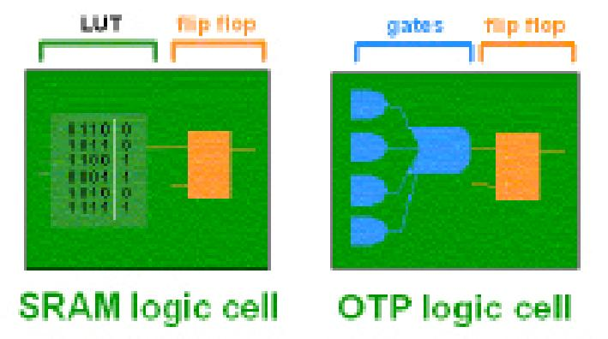

**Fig 4.1: Types of FPGA’S**

In the SRAM logic cell, instead of conventional gates, an LUT determines the output based on the values of the inputs. (In the “SRAM logic cell” diagram above, six different combinations of the four inputs determine the values of the output.) SRAM bits are also used to make connections. OTP FPGAs use anti-fuses (contrary to fuses, connections are made, not “blown”, during programming) to make permanent connections in the chip. Thus, OTP FPGAs do not require SPROM or other means to download the program to the FPGA. However, every time you make a design change, you must throw away the chip! The OTP logic cell is very similar to PLDs, with dedicated gates and flip-flops.

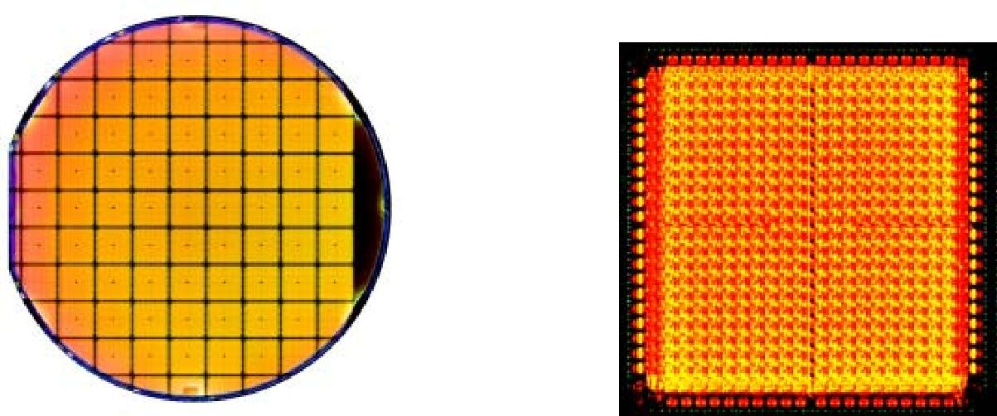

**Fig 4.2 Silicon Wafer containing Figure 4.3 Single FPGA Die**

**10,000 gate FPGA’s**

**4.4 INTERNAL STRUCTURE OF FPGA**

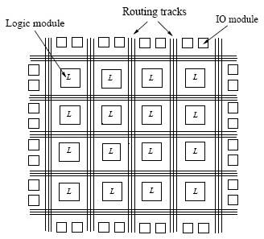 A typical FPGA is composed of three major components: logic modules, routing resources, and input/output (I/O modules) Figure 4.4 depicts the conceptual FPGA model. In an FPGA, an array of logic modules is surrounded or overlapped by general routing resources bounded by I/O modules. The logic modules contain combinational and sequential circuits that implement logic functions. The routing resources comprise pre-fabricated wire segments and programmable switches. The interconnections between the logic modules and the I/O modules are user programmable.

**Fig 4.4: A typical FPGA architecture with three major components:**

**Logic modules, routing resources, and I/O modules.**

**4.5 PROGRAMMING TECHNOLOGIES**

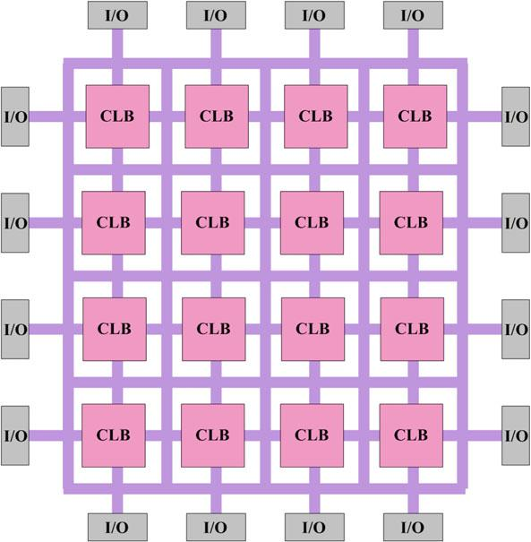There are a number of programming technologies that have been used for reconfigurable architectures. Each of these technologies has different characteristics which in turn have significant effect on the programmable architecture. Some of the well known technologies include static memory, flash, and anti-fuse.

**Fig. 4.5: Overview of FPGA architecture**

**4.5.1 SRAM-BASED PROGRAMMING TECHNOLOGY**

Static memory cells are the basic cells used for SRAM-based FPGAs. Most commercial vendors [76, 126] use static memory (SRAM) based programming technology in their devices. These devices use static memory cells which are divided throughout the FPGA to provide configurability. An example of such memory cell is shown in Fig.4.7.In an SRAM-based FPGA, SRAM cells are mainly used for following purposes:

1. To program the routing interconnect of FPGAs which are generally steered by small multiplexors.
2. To program Configurable Logic Blocks (CLBs) those are used to implement logic functions.

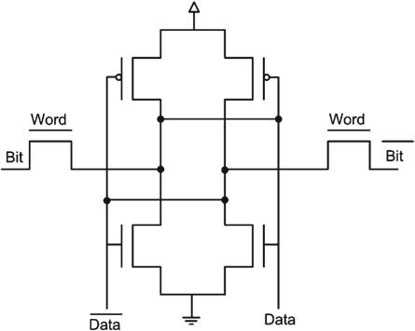SRAM-based programming technology has become the dominant approach for FPGAs because of its re-programmability and the use of standard CMOS process technology and therefore leading to increased integration, higher speed and lower dynamic power consumption of new process with smaller geometry.



**Fig. 4.6: Static memory cell**

There are how-ever a number of drawbacks associated with SRAM-based programming technology. For example an SRAM cell requires 6 transistors which make the use of this technology costly in terms of area compared to other programming technologies. Further SRAM cells are volatile in nature and external devices are required to permanently store the configuration data. These external devices add to the cost and area overhead of SRAM-based FPGAs.

**4.5.2 FLASHPROGRAMMING TECHNOLOGY**

One alternative to the SRAM-based programming technology is the use of flash or EEPROM based programming technology. Flash-based programming technology offers several advantages. For example, this programming technology is non-volatile in nature. Flash-based programming technology is also more area efficient than SRAM-based programming technology. Flash-based programming technology has its own disadvantages also. Unlike SRAM-based programming technology, flash-based devices cannot be reconfigured/reprogrammed an infinite number of times. Also, flash-based technology uses non-standard CMOS process.

**4.5.3 ANTIFUSE PROGRAMMING TECHNOLOGY**

An alternative to SRAM and flash-based technologies is anti-fuse programming technology. The primary advantage of anti-fuse programming technology is its low area. Also this technology has lower on resistance and parasitic capacitance than other two programming technologies. Further, this technology is non-volatile in nature. There is however significant disadvantages associated with this programming technology. For example, this technology does not make use of standard CMOS process. Also, anti-fuse programming technology based devices cannot be reprogrammed.

In this section, an overview of three commonly used programming technologies is given where all of them have their advantages and disadvantages. Ideally, one would like to have a programming technology which is reprogrammable, non-volatile, and that uses a standard CMOS process. Apparently, none of the above presented technologies satisfy these conditions. However, SRAM-based programming technology is the most widely used programming technology. The main reason is its use of standard CMOS process and for this very reason, it is expected that this technology will continue to dominate the other two programming technologies.

**4.6 CONFIGURABLE LOGIC BLOCK**

A configurable logic block (CLB) is a basic component of an FPGA that provides the basic logic and storage functionality for a target application design. In order to provide the basic logic and storage capability, the basic component can be either a transistor or an entire processor. However, these are the two extremes where at one end the basic component is very fine-grained (in case of transistors) and requires large amount of programmable interconnect which eventually results in an FPGA that suffers from area-inefficiency, low performance and high power consumption. On the other end (in case of processor), the basic logic block is very coarse-grained and cannot be used to implement small functions as it will lead to wastage of resources. In between these two extremes, there exists a spectrum of basic logic blocks. Some of them include logic blocks that are made of NAND gates; an interconnection of multiplexors, and lookup table (LUT) and PAL style wide input gates. Commercial vendors like XILINX and ALTERA use LUT-based CLBs to provide basic logic and storage functionality. LUT-based CLBs provide a good trade-off between too fine-grained and too coarse-grained logic blocks. A CLB can comprise of a single basic logic element (BLE), or a cluster of locally interconnected BLEs (as shown in Fig.4.8).

A simple BLE consists of a LUT, and a Flip-Flop. A LUT with k inputs (LUT-k) contains 2*k* configuration bits and it can implement any k-input Boolean function. Figure 4.8 shows a simple BLE comprising of a 4 input LUT (LUT-4) and a D-type Flip-Flop. The LUT-4 uses 16 SRAM bits to implement any 4 inputs Boolean function. The output of LUT-4 is connected to an optional Flip-Flop. A multiplexor selects the BLE output to be either the output of a Flip-Flop or the LUT-4.

A CLB can contain a cluster of BLEs connected through a local routing network. Figure 4.8 shows a cluster of 4 BLEs; each BLE contains a LUT-4 and a Flip-Flop. The BLE output is accessible to other BLEs of the same cluster through a local routing network. The number of output pins of a cluster is equal to the total number of BLEs in a cluster (with each BLE having a single output).

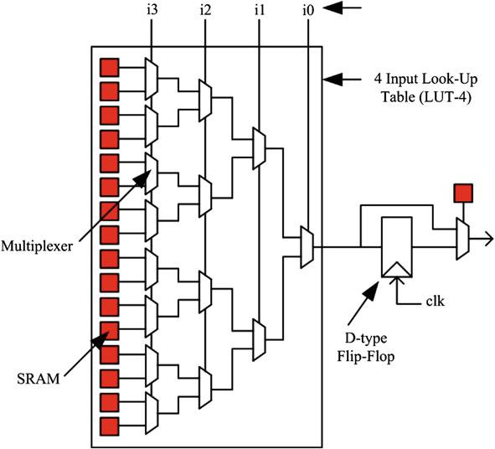

**Fig. 4.7: Basic logic element (BLE)**

However, the number of input pins of a cluster can be less than or equal to the sum of input pins required by all the BLEs in the cluster. Modern FPGAs contain typically 4 to 10 BLEs in a single cluster. Although here we have discussed only basic logic blocks, many modern FPGAs contain a heterogeneous mixture of blocks, some of which can only be used for specific purposes. Theses specific purpose blocks, also referred here as hard blocks, include memory, multipliers, adders and DSP blocks etc. Hard blocks are very efficient at implementing specific functions as they are designed optimally to perform these functions, yet they end up wasting huge amount of logic and routing resources if unused. A detailed discussion on the use of heterogeneous mixture of blocks for implementing digital circuits is presented in Chap. 4 where both advantages and disadvantages of heterogeneous FPGA architectures and a remedy to counter the resource loss problem are discussed in detail.

**4.7 ARCHITECTURE OF FPGA**

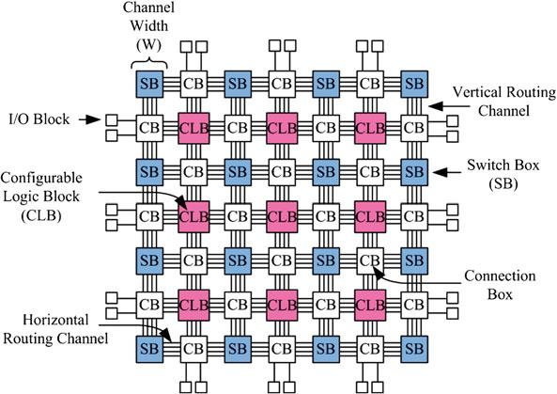As discussed earlier, in an FPGA, the computing functionality is provided by its programmable logic blocks and these blocks connect to each other through programmable routing network. This programmable routing network provides routing connections among logic blocks and I/O blocks to implement any user-defined circuit. The routing interconnect of an FPGA consists of wires and programmable switches that form the required connection. These programmable switches are configured using the programmable technology.

**Fig. 4.8 Overview of mesh-based FPGA architecture**

The routing network of an FPGA occupies 80–90% of total area, whereas the logic area occupies only 10–20% area. The flexibility of an FPGA is mainly dependent on its programmable routing network. A mesh-based FPGA routing network consists of horizontal and vertical routing tracks which are interconnected through switch boxes (SB). Logic blocks are connected to the routing network through connection boxes (CB). The flexibility of a connection box (Fc) is the number of routing tracks of adjacent channel which are connected to the pin of a block. The connectivity of input pins of logic blocks with the adjacent routing channel is called as Fc(in); the connectivity of output pins of the logic blocks with the adjacent routing channel is called as Fc(out). An Fc(in) equal to 1.0 means that all the tracks of adjacent routing channel are connected to the input pin of the logic block. The flexibility of switch box (Fs) is the total number of tracks with which every track entering in the switch.

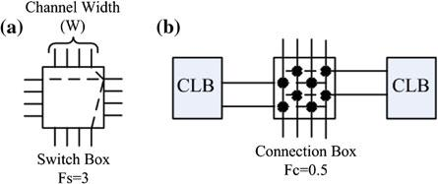

**Fig. 4.9: Example of switch and connection box**

The routing tracks connected through a switch box can be bidirectional or uni-directional (also called as directional) tracks. Figure 4.10 shows a bidirectional and a unidirectional switch box having Fs equal to 3. The input tracks (or wires) in both these switch boxes connect to 3 other tracks of the same switch box. The only limitation of unidirectional switch box is that their routing channel width must be in multiples of 2.

Generally, the output pins of a block can connect to any routing track through pass transistors. Each pass transistor forms a tri-state output that can be independently turned on or off. However, single-driver wiring technique can also be used to connect output pins of a block to the adjacent routing tracks. For single-driver wiring, tristate elements cannot be used; the output of block needs to be connected to the neighboring routing network through multiplexors in the switch box. Modern commercial FPGA architectures have moved towards using single-driver, directional routing tracks. Authors in show that if single-driver directional wiring is used instead of bidirectional wiring, 25% improvement in area, 9% in delay and 32% in area-delay can be achieved. All these advantages are achieved without making any major changes in the FPGA CAD flow.

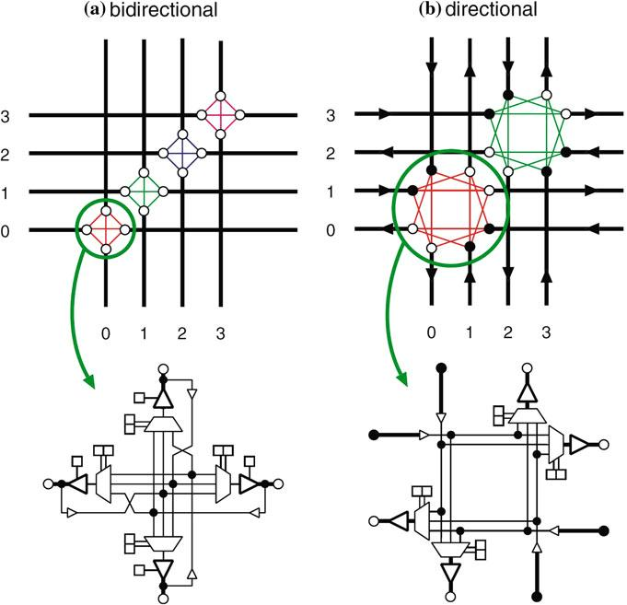

**Fig. 4.10: Switch block-length 1 wires**

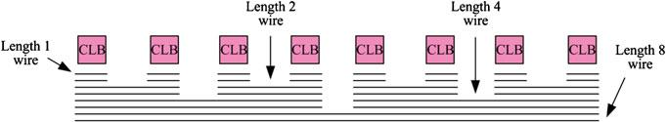

**Fig. 4.11 Channel segment distribution**

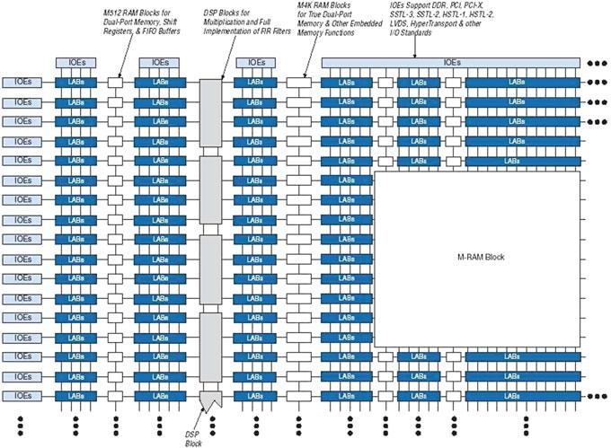Until now, we have presented a general overview about island-style routing architecture. Now we present a commercial example of this kind of architectures. ALTERA’s Stratix II architecture is an industrial example of an island-style FPGA (Figure 4.12). The logic structure consists of LABs (Logic Array Blocks), memory blocks, and digital signal processing (DSP) blocks. LABs are used to implement general-purpose logic, and are symmetrically distributed in rows and columns throughout the device fabric.

**Fig. 4.12 ALTERA’s stratix-II block diagram**

**4.8 APPLICATIONS OF FPGA’S**

FPGA’s have gained rapid acceptance and growth over the past decade because they can be applied to a very wide range of applications. A list of typical applications includes: random logic, integrating multiple SPLDs, device controllers, communication encoding and filtering, small to medium sized systems with SRAM blocks, and many more. Other interesting applications of FPGAs are prototyping of designs later to be implemented in gate arrays, and also emulation of entire large hardware systems. The former of these applications might be possible using only a single large FPGA (which corresponds to a small Gate Array in terms of capacity), and the latter would entail many FPGAs connected by some sort of interconnect; for emulation of hardware, QuickTurn [Wolff90] (and others) has developed products that comprise many FPGAs and the necessary software to partition and map circuits. Another promising area for FPGA application, which is only beginning to be developed, is the usage of FPGAs as custom computing machines. This involves using the programmable parts to “execute” software, rather than compiling the software for execution on a regular CPU. The reader is referred to the FPGA-Based Custom Computing Workshop (FCCM) held for the last four years and published by the IEEE. When designs are mapped into CPLDs, pieces of the design often map naturally to the SPLD-like blocks. However, designs mapped into an FPGA are broken up into logic block-sized pieces and distributed through an area of the FPGA. Depending on the FPGA’s interconnect structure, there may be various delays associated with the interconnections between these logic blocks. Thus, FPGA performance often depends more upon how CAD tools map circuits into the chip than is the case for CPLDs. We believe that over time programmable logic will become the dominant form of digital logic design and implementation. Their ease of access, principally through the low cost of the devices, makes them attractive to small firms and small parts of large companies. The fast manufacturing turn-around they provide is an essential element of success in the market. As architecture and CAD tools improve, the disadvantages of FPDs compared to Mask-Programmed Gate Arrays will lessen, and programmable devices will dominate.

**5. VLSI**

Very-Large-Scale Integration (VLSI) is the process of creating integrated circuits by combining thousands of transistor-based circuits into a single chip. VLSI began in the 1970s when complex semiconductor and communication technologies were being developed. The microprocessor is a VLSI device. The term is no longer as common as it once was, as chips have increased in complexity into the hundreds of millions of transistors.

## 5.1 OVERVIEW OF VLSI

The first semiconductor chips held one transistor each. Subsequent advances added more and more transistors, and, as a consequence, more individual functions or systems were integrated over time. The first integrated circuits held only a few devices, perhaps as many as ten diodes, transistors, resistors and capacitors, making it possible to fabricate one or more logic gates on a single device. Now known retrospectively as "small-scale integration" (SSI), improvements in technique led to devices with hundreds of logic gates, known as large-scale integration (LSI), i.e. systems with at least a thousand logic gates. Current technology has moved far past this mark and today's microprocessors have many millions of gates and hundreds of millions of individual transistors.

At one time, there was an effort to name and calibrate various levels of large-scale integration above VLSI. Terms like Ultra-large-scale Integration (ULSI) were used. But the huge number of gates and transistors available on common devices has rendered such fine distinctions moot. Terms suggesting greater than VLSI levels of integration are no longer in widespread use. Even VLSI is now somewhat quaint, given the common assumption that all microprocessors are VLSI or better.

As of early 2008, billion-transistor processors are commercially available, an example of which is Intel's Montecito Itanium chip. This is expected to become more commonplace as semiconductor fabrication moves from the current generation of 65 nm processes to the next 45 nm generations (while experiencing new challenges such as increased variation across process corners). Another notable example is NVIDIA’s 280 series GPU.

This microprocessor is unique in the fact that its 1.4 Billion transistor count, capable of a teraflop of performance, is almost entirely dedicated to logic (Itanium's transistor count is largely due to the 24MB L3 cache). Current designs, as opposed to the earliest devices, use extensive design automation and automated logic synthesis to lay out the transistors, enabling higher levels of complexity in the resulting logic functionality. Certain high-performance logic blocks like the SRAM cell, however, are still designed by hand to ensure the highest efficiency (sometimes by bending or breaking established design rules to obtain the last bit of performance by trading stability).

**5.2 INTRODUCTION TO VLSI**

VLSI stands for "Very Large Scale Integration". This is the field which involves packing more and more logic devices into smaller and smaller areas.

## VLSI

## Simply we say Integrated circuit is many transistors on one chip.

## Design/manufacturing of extremely small, complex circuitry using modified semiconductor material.

## Integrated circuit (IC) may contain millions of transistors, each a few mm in size.

## Wide ranging applications.

## Most electronic logic devices.

# 5.3 HISTORY OF SCALE INTEGRATION

* Late 40s Transistor invented at Bell Labs.
* Late 50s First IC (JK-FF by Jack Kilby at TI).
* Early 60s Small Scale Integration (SSI).
* 10s of transistors on a chip.
* Late 60s Medium Scale Integration (MSI).
* 100s of transistors on a chip.
* Early 70s Large Scale Integration (LSI).
* 1000s of transistor on a chip.
* Early 80s VLSI 10,000s of transistors on a
* chip (later 100,000s & now 1,000,000s)
* Ultra LSI is sometimes used for 1,000,000s
* SSI - Small-Scale Integration (0-102)
* MSI - Medium-Scale Integration (102-103)
* LSI - Large-Scale Integration (103-105)
* VLSI - Very Large-Scale Integration (105-107)
* ULSI - Ultra Large-Scale Integration (>=107)

### 5.4 ADVANTAGES OF IC’S OVER DISCRETE COMPONENTS

While we will concentrate on integrated circuits, the properties of integrated circuits-what we can and cannot efficiently put in an integrated circuit-largely determine the architecture of the entire system. Integrated circuits improve system characteristics in several critical ways. ICs have three key advantages over digital circuits built from discrete components:

* + **Size:**

Integrated circuits are much smaller-both transistors and wires are shrunk to micrometer sizes, compared to the millimeter or centimeter scales of discrete components. Small size leads to advantages in speed and power consumption, since smaller components have smaller parasitic resistances, capacitances, and inductances.

* + **Speed:**

Signals can be switched between logic 0 and logic 1 much quicker within a chip than they can between chips. Communication within a chip can occur hundreds of times faster than communication between chips on a printed circuit board. The high speed of circuit’s on-chip is due to their small size-smaller components and wires have smaller parasitic capacitances to slow down the signal.

* + **Power consumption:**

Logic operations within a chip also take much less power. Once again, lower power consumption is largely due to the small size of circuits on the chip-smaller parasitic capacitances and resistances require less power to drive them.

#### 5.5 VLSI AND SYSTEMS

These advantages of integrated circuits translate into advantages at the system level:

* + **Smaller physical size:**

Smallness is often an advantage in itself-consider portable televisions or handheld cellular telephones.

* + **Lower power consumption:**

Replacing a handful of standard parts with a single chip reduces total power consumption. Reducing power consumption has a ripple effect on the rest of the system. A smaller, cheaper power supply can be used, since less power consumption means less heat, a fan may no longer be necessary, a simpler cabinet with less shielding for electromagnetic shielding may be feasible, too.

* + **Reduced cost:**

Reducing the number of components, the power supply requirements, cabinet costs, and so on, will inevitably reduce system cost. The ripple effect of integration is such that the cost of a system built from custom ICs can be less, even though the individual ICs cost more than the standard parts they replace.

Understanding why integrated circuit technology has such profound influence on the design of digital systems requires understanding both the technology of IC manufacturing and the economics of ICs and digital systems.

### 5.6 ASIC

An Application-Specific Integrated Circuit (ASIC) is an integrated circuit (IC) customized for a particular use, rather than intended for general-purpose use. For example, a chip designed solely to run a cell phone is an ASIC. Intermediate between ASICs and industry standard integrated circuits, like the 7400 or the 4000 series, are application specific standard products (ASSPs).

As feature sizes have shrunk and design tools improved over the years, the maximum complexity (and hence functionality) possible in an ASIC has grown from 5,000 gates to over 100 million. Modern ASICs often include entire 32-bit processors, memory blocks including ROM, RAM, EEPROM, Flash and other large building blocks. Such an ASIC is often termed a SoC (system-on-a-chip). Designers of digital ASICs use a hardware description language (HDL), such as Verilog or VHDL, to describe the functionality of ASICs.

Field-programmable gate arrays (FPGA) are the modern-day technology for building a breadboard or prototype from standard parts; programmable logic blocks and programmable interconnects allow the same FPGA to be used in many different applications. For smaller designs and/or lower production volumes, FPGAs may be more cost effective than an ASIC design even in production.

## An application-specific integrated circuit (ASIC) is an integrated circuit (IC) customized for a particular use, rather than intended for general-purpose use.

## A Structured ASIC falls between an FPGA and a Standard Cell-based ASIC.

## Structured ASIC’s are used mainly for mid-volume level designs.

## The design task for structured ASIC’s is to map the circuit into a fixed arrangement of known cells.

##### 5.7 APPLICATIONS

* Electronic system in cars.
* Digital electronics control VCRs
* Transaction processing system, ATM
* Personal computers and Workstations
* Medical electronic systems.
* Etc….

Electronic systems now perform a wide variety of tasks in daily life. Electronic systems in some cases have replaced mechanisms that operated mechanically, hydraulically, or by other means; electronics are usually smaller, more flexible, and easier to service. In other cases electronic systems have created totally new applications. Electronic systems perform a variety of tasks, some of them visible, some more hidden:

* + Personal entertainment systems such as portable MP3 players and DVD players perform sophisticated algorithms with remarkably little energy.
  + Electronic systems in cars operate stereo systems and displays; they also control fuel injection systems, adjust suspensions to varying terrain, and perform the control functions required for anti-lock braking (ABS) systems.
  + Digital electronics compress and decompress video, even at high-definition data rates, on-the-fly in consumer electronics.
  + Low-cost terminals for Web browsing still require sophisticated electronics, despite their dedicated function.
  + Personal computers and workstations provide word-processing, financial analysis, and games. Computers include both central processing units (CPUs) and special-purpose hardware for disk access, faster screen display, *etc*.
  + Medical electronic systems measure bodily functions and perform complex processing algorithms to warn about unusual conditions. The availability of these complex systems, far from overwhelming consumers, only creates demand for even more complex systems.

The growing sophistication of applications continually pushes the design and manufacturing of integrated circuits and electronic systems to new levels of complexity. And perhaps the most amazing characteristic of this collection of systems is its variety-as systems become more complex, we build not a few general-purpose computers but an ever wider range of special-purpose systems. Our ability to do so is a testament to our growing mastery of both integrated circuit manufacturing and design, but the increasing demands of customers continue to test the limits of design and manufacturing.

**6. VERILOG HDL**

A typical Hardware Description Language (HDL) supports a mixed-level description in which gate and netlist constructs are used with functional descriptions. This mixed-level capability enables you to describe system architectures at a high level of abstraction, then incrementally refine a design’s detailed gate-level implementation.

**6.1 OVERVIEW**

Verilog is a HARDWARE DESCRIPTION LANGUAGE (HDL). A hardware description Language is a language used to describe a digital system, for example, a microprocessor or a memory or a simple flip-flop. This just means that, by using a HDL one can describe any hardware (digital) at any level.

Verilog provides both behavioral and structural language structures. These structures allow expressing design objects at high and low levels of abstraction. Designing hardware with a language such as Verilog allows using software concepts such as parallel processing and object-oriented programming. Verilog has syntax similar to C and Pascal.

Hardware description languages such as Verilog differ from software [programming languages](http://en.wikipedia.org/wiki/Programming_language) because they include ways of describing the propagation of time and signal dependencies (sensitivity). There are two assignment operators, a blocking assignment (=), and a non-blocking (<=) assignment. The non-blocking assignment allows designers to describe a state-machine update without needing to declare and use temporary storage variables (in any general programming language we need to define some temporary storage spaces for the operands to be operated on subsequently; those are temporary storage variables). Since these concepts are part of Verilog's language semantics, designers could quickly write descriptions of large circuits in a relatively compact and concise form. At the time of Verilog's introduction (1984), Verilog represented a tremendous productivity improvement for circuit designers who were already using graphical [schematic capture](http://en.wikipedia.org/wiki/Schematic_capture)software and specially-written software programs to document and [simulate electronic circuits](http://en.wikipedia.org/wiki/Electronic_circuit_simulation).

The designers of Verilog wanted a language with syntax similar to the [C programming language](http://en.wikipedia.org/wiki/C_(programming_language)), which was already widely used in engineering software development. Verilog is [case-sensitive](http://en.wikipedia.org/wiki/Case-sensitive), has a basic [preprocessor](http://en.wikipedia.org/wiki/Preprocessor) (though less sophisticated than that of ANSI C/C++), and equivalent [control flow](http://en.wikipedia.org/wiki/Control_flow) [keywords](http://en.wikipedia.org/wiki/Keyword_(computer_programming)) (if/else, for, while, case, etc.), and compatible [operator precedence](http://en.wikipedia.org/wiki/Operator_precedence). Syntactic differences include variable declaration (Verilog requires bit-widths on net/reg types), demarcation of procedural blocks (begin/end instead of curly braces {}), and many other minor differences.

A Verilog design consists of a hierarchy of modules. Modules encapsulate design hierarchy, and communicate with other modules through a set of declared input, output, and bidirectional ports. Internally, a module can contain any combination of the following: net/variable declarations (wire, reg, integer, etc.), concurrent and sequential statement blocks, and instances of other modules (sub-hierarchies). Sequential statements are placed inside a begin/end block and executed in sequential order within the block. But the blocks themselves are executed concurrently, qualifying Verilog as a [dataflow language](http://en.wikipedia.org/wiki/Dataflow_language).

Verilog's concept of 'wire' consists of both signal values (4-state: "1, 0, floating, undefined") and strengths (strong, weak, etc.). This system allows abstract modeling of shared signal lines, where multiple sources drive a common net. When a wire has multiple drivers, the wire's (readable) value is resolved by a function of the source drivers and their strengths.

A subset of statements in the Verilog language is [synthesizable](http://en.wikipedia.org/wiki/Logic_synthesis). Verilog modules that conform to a synthesizable coding style, known as RTL (register-transfer level), can be physically realized by synthesis software. Synthesis software algorithmically transforms the (abstract) Verilog source into a [net list](http://en.wikipedia.org/wiki/Netlist), a logically equivalent description consisting only of elementary logic primitives (AND, OR, NOT, flip-flops, etc.) that are available in a specific [FPGA](http://en.wikipedia.org/wiki/FPGA) or [VLSI](http://en.wikipedia.org/wiki/VLSI) technology. Further manipulations to the net list ultimately lead to a circuit fabrication blueprint (such as a [photo mask set](http://en.wikipedia.org/wiki/Mask_set) for an [ASIC](http://en.wikipedia.org/wiki/Application-specific_integrated_circuit) or a [bit stream](http://en.wikipedia.org/wiki/Bitstream) file for an [FPGA](http://en.wikipedia.org/wiki/FPGA)).

## 6.2 HISTORY

### 6.2. 1 BEGINNING

Verilog was the first modern hardware description language to be invented. It was created by [Phil Moorby](http://en.wikipedia.org/wiki/Phil_Moorby) and [Prabhu Goel](http://en.wikipedia.org/w/index.php?title=Prabhu_Goel&action=edit&redlink=1) during the winter of 1983/1984. The wording for this process was "Automated Integrated Design Systems" (later renamed to [Gateway Design Automation](http://en.wikipedia.org/wiki/Gateway_Design_Automation) in 1985) as a hardware modeling language. Gateway Design Automation was purchased by [Cadence Design Systems](http://en.wikipedia.org/wiki/Cadence_Design_Systems) in 1990. Cadence now has full proprietary rights to Gateway's Verilog and the Verilog-XL, the HDL-simulator that would become the de-facto standard (of Verilog [logic simulators](http://en.wikipedia.org/wiki/Logic_simulator)) for the next decade. Originally, Verilog was intended to describe and allow simulation; only afterwards was support for synthesis added.

### 6.2.2 VERILOG 1995

With the increasing success of [VHDL](http://en.wikipedia.org/wiki/VHDL) at the time, Cadence decided to make the language available for open [standardization](http://en.wikipedia.org/wiki/Standardization). Cadence transferred Verilog into the public domain under the [Open Verilog International](http://www.ovi.org/)  (OVI) (now known as [Accellera](http://en.wikipedia.org/wiki/Accellera)) organization. Verilog was later submitted to [IEEE](http://en.wikipedia.org/wiki/IEEE) and became IEEE Standard 1364-1995, commonly referred to as Verilog-95.

In the same time frame Cadence initiated the creation of [Verilog-A](http://en.wikipedia.org/wiki/Verilog-A) to put standards support behind its analog simulator [Spectre](http://en.wikipedia.org/wiki/Spectre_Circuit_Simulator). Verilog-A was never intended to be a standalone language and is a subset of [Verilog-AMS](http://en.wikipedia.org/wiki/Verilog-AMS) which encompassed Verilog-95.

### 6.2.3 VERILOG 2001

Extensions to Verilog-95 were submitted back to IEEE to cover the deficiencies that users had found in the original Verilog standard. These extensions became [IEEE](http://en.wikipedia.org/wiki/IEEE) Standard 1364-2001 known as Verilog-2001.

Verilog-2001 is a significant upgrade from Verilog-95. First, it adds explicit support for (2's complement) signed nets and variables. Previously, code authors had to perform signed operations using awkward bit-level manipulations (for example, the carry-out bit of a simple 8-bit addition required an explicit description of the Boolean algebra to determine its correct value). The same function under Verilog-2001 can be more succinctly described by one of the built-in operators: +, -, /, *, >>>. A generate/degenerate construct (similar to VHDL's generate/degenerate) allows Verilog-2001 to control instance and statement instantiation through normal decision operators (case/if/else). Using generate/degenerate, Verilog-2001 can instantiate an array of instances, with control over the connectivity of the individual instances. File I/O has been improved by several new system tasks. And finally, a few syntax additions were introduced to improve code readability (e.g. always @*, named parameter override, C-style function/task/module header declaration).

Verilog-2001 is the dominant flavor of Verilog supported by the majority of commercial [EDA](http://en.wikipedia.org/wiki/Electronic_design_automation) software packages.

### 6.2.4 VERILOG 2005

Not to be confused with [System Verilog](http://en.wikipedia.org/wiki/SystemVerilog), Verilog *2005* ([IEEE](http://en.wikipedia.org/wiki/IEEE) Standard 1364-2005) consists of minor corrections, spec clarifications, and a few new language features (such as the uwire keyword).

A separate part of the Verilog standard, [Verilog-AMS](http://en.wikipedia.org/wiki/Verilog-AMS), attempts to integrate analog and mixed signal modeling with traditional Verilog.

### 6.2.5 SYSTEM VERILOG

SystemVerilog is a [superset](http://en.wikipedia.org/wiki/Superset) of Verilog-2005, with many new features and capabilities to aid design verification and design modeling. As of 2009, the SystemVerilog and Verilog language standards were merged into SystemVerilog 2009 (IEEE Standard 1800-2009).

The advent of [hardware verification languages](http://en.wikipedia.org/wiki/Hardware_verification_language) such as [OpenVera](http://en.wikipedia.org/wiki/OpenVera), and [Verisity](http://en.wikipedia.org/w/index.php?title=Verisity&action=edit&redlink=1)'s [e language](http://en.wikipedia.org/wiki/E_(verification_language)) encouraged the development of [Superlog](http://en.wikipedia.org/wiki/Superlog) by [Co-Design Automation Inc](http://en.wikipedia.org/w/index.php?title=Co-Design_Automation_Inc&action=edit&redlink=1). Co-Design Automation Inc was later purchased by [Synopsys](http://en.wikipedia.org/wiki/Synopsys). The foundations of Superlog and Vera were donated to [Accellera](http://en.wikipedia.org/wiki/Accellera), which later became the IEEE standard P1800-2005: SystemVerilog.

In the late 1990s, the Verilog Hardware Description Language (HDL) became the most widely used language for describing hardware for simulation and synthesis. However, the first two versions standardized by the IEEE (1364-1995 and 1364-2001) had only simple constructs for creating tests. As design sizes outgrew the verification capabilities of the language, commercial Hardware Verification Languages (HVL) such as Open Vera and e were created. Companies that did not want to pay for these tools instead spent hundreds of man-years creating their own custom tools. This productivity crisis (along with a similar one on the design side) led to the creation of Accellera, a consortium of EDA companies and users who wanted to create the next generation of Verilog. The donation of the Open-Vera language formed the basis for the HVL features of SystemVerilog.Accellera’s goal was met in November 2005 with the adoption of the IEEE standard P1800-2005 for SystemVerilog, IEEE (2005).

The most valuable benefit of SystemVerilog is that it allows the user to construct reliable, repeatable verification environments, in a consistent syntax, that can be used across multiple projects.

Some of the typical features of an HVL that distinguish it from a Hardware Description Language such as Verilog or VHDL are:

* Constrained-random stimulus generation.
* Functional coverage.
* Higher-level structures, especially Object Oriented Programming.
* Multi-threading and interprocess communication.
* Support for HDL types such as Verilog’s 4-state values.
* Tight integration with event-simulator for control of the design.

There are many other useful features, but these allow you to create test benches at a higher level of abstraction than you are able to achieve with an HDL or a programming language such as C.

System Verilog provides the best framework to achieve coverage-driven verification (CDV). CDV combines automatic test generation, self-checking testbenches, and coverage metrics to significantly reduce the time spent verifying a design.

The purpose of CDV is to:

* Eliminate the effort and time spent creating hundreds of tests.
* Ensure thorough verification using up-front goal setting.
* Receive early error notifications and deploy run-time checking and error analysis to simplify debugging.

**6.3 DESIGN STYLES**

Verilog like any other hardware description language permits the designers to create a design in either Bottom-up or Top-down methodology.

**6.3.1 BOTTOM-UP DESIGN**

The traditional method of electronic design is bottom-up. Each design is performed at the gate-level using the standard gates. With increasing complexity of new designs this approach is nearly impossible to maintain. New systems consist of ASIC or microprocessors with a complexity of thousands of transistors. These traditional bottom-up designs have to give way to new structural, hierarchical design methods. Without these new design practices it would be impossible to handle the new complexity.

**6.3.2 TOP-DOWN DESIGN**

The desired design-style of all designers is the top-down design. A real top-down design allows early testing, easy change of different technologies, a structured system design and offers many other advantages. But it is very difficult to follow a pure top-down design. Due to this fact most designs are mix of both the methods, implementing some key elements of both design styles.

Complex circuits are commonly designed using the top down methodology. Various specification levels are required at each stage of the design process.

**6.4 ABSTRACTION LEVELS OF VERILOG**

Verilog supports a design at many different levels of abstraction.

Three of them are very important:

* Behavioral level.
* Register-Transfer Level
* Gate Level

**6.4.1 BEHAVIORAL LEVEL**

This level describes a system by concurrent algorithms (Behavioral). Each algorithm itself is sequential, that means it consists of a set of instructions that are executed one after the other. Functions, Tasks and Always blocks are the main elements. There is no regard to the structural realization of the design.

**6.4.2 REGISTER-TRANSFER LEVEL**

Designs using the Register-Transfer Level specify the characteristics of a circuit by operations and the transfer of data between the registers. An explicit clock is used. RTL design contains exact timing possibility, operations are scheduled to occur at certain times. Modern definition of a RTL code is "Any code that is synthesizable is called RTL code".

**6.4.3 GATE LEVEL**

Within the logic level the characteristics of a system are described by logical links and their timing properties. All signals are discrete signals. They can only have definite logical values (`0', `1', `X', `Z`). The usable operations are predefined logic primitives (AND, OR, NOT etc gates). Using gate level modeling might not be a good idea for any level of logic design. Gate level code is generated by tools like synthesis tools and this Netlist is used for gate level simulation and for backend.

**6.5 VLSI DESIGN FLOW**

Design is the most significant human endeavor: It is the channel through which creativity is realized. Design determines our every activity as well as the results of those activities; thus it includes planning, problem solving, and producing. Typically, the term “design” is applied to the planning and production of artifacts such as jewelry, houses, cars, and cities. Design is also found in problem-solving tasks such as mathematical proofs and games. Finally, design is found in pure planning activities such as making a law or throwing a party.

More specific to the matter at hand is the design of manufacturable artifacts. This activity uses all facets of design because, in addition to the specification of a producible object, it requires the planning of that object's manufacture, and much problem solving along the way. Design of objects usually begins with a rough sketch that is refined by adding precise dimensions. The final plan must not only specify exact sizes, but also include a scheme for ordering the steps of production. Additional considerations depend on the production environment; for example, whether one or ten million will be made, and how precisely the manufacturing environment can be controlled.

A semiconductor process technology is a method by which working circuits can be manufactured from designed specifications. There are many such technologies, each of which creates a different environment or style of design.

**6.5 ADVANTAGES**

* We can verify design functionality early in the design process. A design written as an HDL description can be simulated immediately. Design simulation at this high level — at the gate-level before implementation — allows you to evaluate architectural and design decisions.
* An HDL description is more easily read and understood than a netlist or schematic description. HDL descriptions provide technology-independent documentation of a design and its functionality. Because the initial HDL design description is technology independent, you can use it again to generate the design in a different technology, without having to translate it from the original technology.
* Large designs are easier to handle with HDL tools than schematic tools.

**7. XILINX**

**7.1 MIGRATING PROJECTS FROM PREVIOUS ISE SOFTWARE RELEASES**

When you open a project file from a previous release, the ISE® software prompts you to migrate your project. If you click Backup and Migrate or Migrate only, the software automatically converts your project file to the current release. If you click Cancel, the software does not convert your project and, instead, opens Project Navigator with no project loaded.

**Note:** After you convert your project, you cannot open it in previous versions of the ISE software, such as the ISE 11 software. However, you can optionally create a backup of the original project as part of project migration, as described below.

**To Migrate a Project:**

1. In the ISE 12 Project Navigator, select **File > Open Project**.
2. In the Open Project dialog box, select the .xise file to migrate.

**Note:** You may need to change the extension in the Files of type field to display .npl (ISE 5 and ISE 6 software) or .ise (ISE 7 through ISE 10 software) project files.

1. In the dialog box that appears, select **Backup and Migrate** or **Migrate Only**.
2. The ISE software automatically converts your project to an ISE 12 project.

**Note:** If you chose to Backup and Migrate, a backup of the original project is created at *project_name_*ise12migration.zip.

1. Implement the design using the new version of the software.

**Note:**Implementation status is not maintained after migration.

**7.2 PROPERTIES**

For information on properties that have changed in the ISE 12 software, see [ISE 11 to ISE 12 Properties Conversion](ise_r_properties_conversion.htm).

**7.3 IP MODULES**

If your design includes IP modules that were created using CORE Generator™ software or Xilinx® Platform Studio (XPS) and you need to modify these modules, you may be required to update the core. However, if the core netlist is present and you do not need to modify the core, updates are not required and the existing netlist is used during implementation.

**7.4 OBSOLETE SOURCE FILE TYPES**

The ISE 12 software supports all of the source types that were supported in the ISE 11 software.

If you are working with projects from previous releases, state diagram source files (.dia), ABEL source files (.abl), and test bench waveform source files (.tbw) are no longer supported. For state diagram and ABEL source files, the software finds an associated HDL file and adds it to the project, if possible. For test bench waveform files, the software automatically converts the TBW file to an HDL test bench and adds it to the project. To convert a TBW file after project migration, see [Converting a TBW File to an HDL Test Bench](pn_p_converting_tbw.htm).

**7.5 USING ISE EXAMPLE PROJECTS**

To help familiarize you with the ISE® software and with FPGA and CPLD designs, a set of example designs is provided with Project Navigator. The examples show different design techniques and source types, such as VHDL, Verilog, schematic, or EDIF, and include different constraints and IP.

**7.5.1 TO OPEN AN EXAMPLE**

1. Select **File > Open Example**.
2. In the [Open Example dialog box](pn_db_open_example_project.htm), select the Sample Project Name.

**Note:** To help you choose an example project, the Project Description field describes each project. In addition, you can scroll to the right to see additional fields, which provide details about the project.

**3.** In the Destination Directory field, enter a directory name or browse to the directory.

**4.** Click **OK**.

The example project is extracted to the directory you specified in the Destination Directory field and is automatically opened in Project Navigator. You can then run processes on the example project and save any changes.

**Note:**If you modified an example project and want to overwrite it with the original example project, select **File > Open Example**, select the Sample Project Name, and specify the same Destination Directory you originally used. In the dialog box that appears, select **Overwrite the existing project** and click **OK**.

**7.5.2 CREATING A PROJECT**

Project Navigator allows you to manage your FPGA and CPLD designs using an ISE® project, which contains all the source files and settings specific to your design. First, you must create a project and then, add source files, and set process properties. After you create a project, you can run processes to implement, constrain, and analyze your design. Project Navigator provides a wizard to help you create a project as follows.

**Note:** If you prefer, you can create a project using the [New Project dialog box](pn_db_new_project.htm) instead of the New Project Wizard. To use the New Project dialog box, deselect the **Use New Project wizard** option in the [ISE General page](pn_db_ise_general_options.htm) of Preferences dialog box.

**To Create a Project:**

1. Select **File > New Project** to launch the New Project Wizard.
2. In the [Create New Project page](pn_db_npw_create_new_project.htm), set the name, location, and project type, and click **Next**.
3. For EDIF or NGC/NGO projects only: In the [Import EDIF/NGC Project page](pn_db_npw_import_edif_ngc_project.htm), select the input and constraint file for the project, and click **Next**.
4. In the [Project Settings page](pn_db_npw_device_properties.htm), set the device and project properties, and click **Next**.
5. In the [Project Summary page](pn_db_npw_project_summary.htm), review the information, and click **Finish** to create the project.

Project Navigator creates the project file (*project_name*.xise) in the directory you specified. After you add source files to the project, the files appear in the Hierarchy pane of the [Design panel](pn_r_design_panel.htm). Project Navigator manages your project based on the design properties (top-level module type, device type, synthesis tool, and language) you selected when you created the project. It organizes all the parts of your design and keeps track of the processes necessary to move the design from design entry through implementation to programming the targeted Xilinx® device.

**Note:**For information on changing design properties, see [Changing Design Properties](pn_p_changing_design_properties.htm).

You can now perform any of the following:

* Create new source files for your project.
* Add existing source files to your project.
* Run processes on your source files.
* Modify process properties.

**7.5.3 CREATING A COPY OF A PROJECT**

You can create a copy of a project to experiment with different source options and implementations. Depending on your needs, the design source files for the copied project and their location can vary as follows:

* Design source files are left in their existing location and the copied project points to these files.
* Design source files, including generated files, are copied and placed in a specified directory.
* Design source files, excluding generated files, are copied and placed in a specified directory.

Copied projects are the same as other projects in both form and function. For example, you can do the following with copied projects:

* Open the copied project using the File > Open Project menu command.
* View, modify, and implement the copied project.
* Use the Project Browser to view key summary data for the copied project and then, open the copied project for further analysis and implementation, as described in [Using the Project Browser](ise_c_project_browser.htm).

**Note:**Alternatively, you can create an archive of your project, which puts all of the project contents into a ZIP file. Archived projects must be unzipped before being opened in Project Navigator. For information on archiving, see [Creating a Project Archive](ise_c_project_archive.htm).

**To Create a Copy of a Project:**

1. Select **File > Copy Project**.
2. In the Copy Project dialog box, enter the **Name** for the copy.

**Note:**The name for the copy can be the same as the name for the project, as long as you specify a different location.

1. Enter a directory **Location** to store the copied project.
2. Optionally, enter a **Working directory**.
3. By default, this is blank, and the working directory is the same as the project directory. However, you can specify a working directory if you want to keep your ISE® project file (.xise extension) separate from your working area.
4. Optionally, enter a **Description** for the copy.

The description can be useful in identifying key traits of the project for reference later.

1. In the Source options area, do the following:

* Select one of the following options:
* **Keep sources in their current locations -** to leave the design source files in their existing location.
* If you select this option, the copied project points to the files in their existing location. If you edit the files in the copied project, the changes also appear in the original project, because the source files are shared between the two projects.
* **Copy sources to the new location -** to make a copy of all the design source files and place them in the specified Location directory.
* If you select this option, the copied project points to the files in the specified directory. If you edit the files in the copied project, the changes do not appear in the original project, because the source files are not shared between the two projects.
* Optionally, select **Copy files from Macro Search Path directories** to copy files from the directories you specify in the Macro Search Path property in the [Translate Properties](pp_db_translate_properties.htm) dialog box. All files from the specified directories are copied, not just the files used by the design.

**Note:**If you added a netlist source file directly to the project as described in [Working with Netlist-Based IP](ise_c_using_fixed_netlist_ip.htm), the file is automatically copied as part of Copy Project because it is a project source file. Adding netlist source files to the project is the preferred method for incorporating netlist modules into your design, because the files are managed automatically by Project Navigator.

* Optionally, click **Copy Additional Files** to copy files that were not included in the original project. In the Copy Additional Files dialog box, use the **Add Files** and **Remove Files** buttons to update the list of additional files to copy. Additional files are copied to the copied project location after all other files are copied.

1. To exclude generated files from the copy, such as implementation results and reports, select **Exclude generated files from the copy**.
2. When you select this option, the copied project opens in a state in which processes have not yet been run.
3. To automatically open the copy after creating it, select **Open the copied project**.

**Note:**By default, this option is disabled. If you leave this option disabled, the original project remains open after the copy is made.

1. Click **OK**.

**6.5.4 CREATING A PROJECT ARCHIVE**

A project archive is a single, compressed ZIP file with a .zip extension. By default, it contains all project files, source files, generated files, including following:

* User-added sources and associated files.
* Remote sources.
* Verilog include files.
* Files in the macro search path.
* Generated files.
* Non-project files.

**To Archive a Project:**

1. Select **Project > Archive**.
2. In the Project Archive dialog box, specify a file name and directory for the ZIP file.
3. Optionally, select **Exclude generated files from the archive** to exclude generated files and non-project files from the archive.
4. Click **OK**.

A ZIP file is created in the specified directory. To open the archived project, you must first unzip the ZIP file, and then, you can open the project.

**Note:**Sources that reside outside of the project directory are copied into a remote_sources subdirectory in the project archive. When the archive is unzipped and opened, you must either specify the location of these files in the remote_sources subdirectory for the unzipped project, or manually copy the sources into their original location.

**8. BLOCK DIAGRAM**

**BLOCK DIAGRAM OF TRAFFIC LIGHT CONTROLLER SYSTEM**

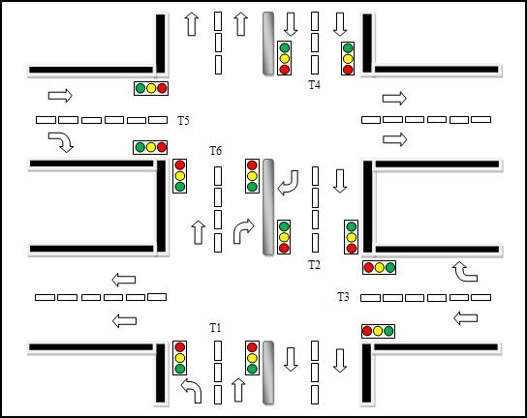

**Fig 8.1 Block diagram of Traffic Light Controller System**

**9. THE STATE MACHINE**

**9.1 THE FINITE STATE MACHINE**

The FSM-FINITE STATE MACHINE is the heart of traffic light controller. It responds to the input signals processed by the input handling module and provides the output and control signals needed to make the system function. This design uses a standard two process finite state machine where one process is used to change states on every clock cycle while the other process is used to combinatorically calculate what the next state should be based on the current inputs and the current state. That combinatorial process also sets the outputs for the next clock cycle.

The FSM has four main groups of states corresponding to the four modes in which the traffic light controller can operate. The read function causes the controller to enter the memory read state. Once in that state, the system remains there until reset, using whatever value is on the timing parameter selection switches for the RAM address. The memory read state also ensures that write enable for the RAM is disabled since the system is only trying to read previously stored values in RAM. The second major state group corresponds to the memory write function. In this mode, the FSM transitions to the memory write state and then returns to the start state. When in the memory write state, the system uses the value of the timing parameter selection switches for the RAM address lines as in the memory read state, but asserts the memory write enable control signal. This ensures that the new value is actually written to RAM. One crucial feature of this design is that the system is only in the memory write state for one cycle; thus the RAM write enable is never high for more than a single clock cycle. That ensures that we never write to the RAM while either data or address values are changing.

**9.1.1 DEFINITION OF THE FSM**

Finite State Machine (FSM) or Finite State Automation, or simply a state machine, is a mathematical abstraction sometimes used to design digital logic or computer programs. It is a behavior model composed of a finite number of states, transitions between those states, and actions, similar to a flow graph in which one can inspect the way logic runs when certain conditions are met. It has finite internal memory, an input feature that reads symbols in a sequence, one at a time without going backward; and an output feature, which may be in the form of a user interface, once the model is implemented. The operation of an FSM begins from one of the states (called a start state), goes through transitions depending on input to different states and can end in any of those available, however only a certain set of states mark a successful flow of operation (called accept states).

**9.1.2 NOTION OF STATES IN SEQUENTIAL MACHINES:**

A state machine is a type of sequential circuit structure which can allow you to create more elaborate types of digital systems. A state machine consists of:

1. Memory elements (e.g. D flip-flops) to store the current state.
2. Combinational logic to compute the next state.
3. Combinational logic to compute the output.

**9.1.2.1 WORKING PRINCIPLE OF AN FSM**

Finite state machines consist of 4 main elements:

* States which define behavior and may produce actions.
* State transitions which are movement from one state to another.
* Rules or conditions which must be met to allow a state transition.
* Input events which are either externally or internally generated, which may possibly trigger rules and lead to state transitions.

A current stateis determined by past states of the system. As such, it can be said to record information about the past, i.e., it reflects the input changes from the system start to the present moment. The number and names of the states typically depend on the different possible states of the memory, e.g. if the memory is three bits long, there are 8 possible states. A transitionindicates a state change and is described by a condition that would need to be fulfilled to enable the transition. An actionis a description of an activity that is to be performed at a given moment. There are several action types:

**Entry action**

This is performed when entering the state.

**Exit action**

This is performed when exiting the state.

**Input action**

This is performed depending on present state and input conditions.

**Transition action**

This is performed when performing a certain transition.

**9.1.3 IMPLEMENTATION OF A FSM**

**State Variable:** The variable held in the SM (FF) that determines its present state.

A basic FSM has a memory section that holds the present state of the machine (stored in FF) and a control section that controls the next state of the machine (by clocks, inputs, and present state).The outputs and internal flip flops (FF) progress through a predictable sequence of states in response to a clock and other control inputs.

A finite state machine must have an initial state which provides a starting point, and a current state which remembers the product of the last state transition. Received input events act as triggers, which cause an evaluation of some kind of the rules that govern the transitions from the current state to other states. The best way to visualize a FSM is to think of it as a flow chart or a directed graph of states, though as will be shown; there are more accurate abstract modeling techniques that can be used.



**Fig 9.1 A Possible Finite State Machine**

**9.1.4 ADVANTAGES OF FSM**

* Their simplicity make it easy for inexperienced developers to implement with little to no extra knowledge (low entry level)
* Predictability (in deterministic FSM), given a set of inputs and a known current state, the state transition can be predicted, allowing for easy testing
* Due to their simplicity, FSMs are quick to design, quick to implement and quick in execution
* FSM is an old knowledge representation and system modeling technique, and its been around for a long time, as such it is well proven even as an artificial intelligence technique, with lots of examples to learn from
* FSMs are relatively flexible. There are a number of ways to implement a FSM based system in terms of topology, and it is easy to incorporate many other techniques
* Easy to transfer from a meaningful abstract representation to a coded implementation
* Low processor overhead; well suited to domains where execution time is shared between modules or subsystems. Only the code for the current state need be executed, and perhaps a small amount of logic to determine the current state.
* Easy determination of reachability of a state, when represented in an abstract form, it is immediately obvious whether a state is achievable from another state, and what is required to achieve the state.

**9.2 TYPES OF STATE MACHINES**

There are two basic ways to design clocked sequential circuits, i.e., the state machines.

**9.2.1 MEALY MACHINE**

In the theory of computation, a Mealy machine is a finite-state machine whose output values are determined by both its current state and by the values of its inputs. The state diagram for a Mealy machine associates an output value with each transition edge (in contrast to the state diagram for a Moore machine, which associates an output value with each state). In a Mealy machine, the outputs are a function of the present state and the value of the inputs. Accordingly, the outputs may change asynchronously in response to any change in the inputs. A combinational logic block maps the inputs and the current state into the necessary flip-flop inputs to store the appropriate next state just like Mealy machine. However, the outputs are computed by a combinational logic block whose inputs are only the flip-flops state outputs.



**Fig 9.2 Mealy Machine**

**9.2.2 MOORE MACHINE**

A **Moore machine** is a finite-state machine whose output values are determined solely by its current state. (This is in contrast to a Mealy machine, whose output values are determined both by its current state and by the values of its inputs.) The state diagram for a Moore machine associates an output value with each state (in contrast to the state diagram for a Mealy machine, which associates an output value with each transition edge).

A combinational logic block maps the inputs and the current state into the necessary flip-flop inputs to store the appropriate next state just like Mealy machine. However, the outputs are computed by a combinational logic block whose inputs are only the flip-flops state outputs. The outputs change synchronously with the state transition triggered by the active clock edge.



**Fig 9.3 Moore machine**

**9.2.3 MECHANISM**

Most digital electronic systems are designed as clocked sequential systems. Clocked sequential systems are a restricted form of Moore machine where the state changes only when the global clock signal changes. Typically the current state is stored in flip-flops, and a global clock signal is connected to the "clock" input of the flip-flops. A typical electronic Moore machine includes a combinational logic chain to decode the current state into the outputs (lambda). The instant the current state changes, those changes ripple through that chain, and almost instantaneously the outputs change (or don't change). There are design techniques to ensure that no glitches occur on the outputs during that brief period while those changes are rippling through the chain, but most systems are designed so that glitches during that brief transition time are ignored or are irrelevant. The outputs then stay the same indefinitely (LEDs stay bright, power stays connected to the motors, solenoids stay energized, etc.), until the Moore machine changes state again.

**9.2.4 FSM DESIGN TECHNIQUES**

FSM’s can be designed in two appropriate ways.

**Classical Design**:

Makes use of state tables, FF excitation tables, and Karnaugh Mapping to find FF input control logic.

**VHDL Design**:

Uses case statements or IF THEN ELSE statements to set the design and the logic synthesis tools to define equation.

**9.2.5 CLASSICAL DESIGN APPROACH**

1. Define the actual problem.
2. Draw a state diagram (bubble) to implement the problem.
3. Make a state table. Define all present states and inputs in a binary sequence.
4. Then define the next states and outputs from the state diagram.
5. Use FF excitation tables to determine in what states the FF inputs must be to cause a present state to next state transition.
6. Find the output values for each present state/input combination.
7. Simplify Boolean logic for each FF input and output equations and design logic.

**9.2.6 VHDL FSM DESIGN APPROACH**

* Uses an enumerated type to declare state variables.
* Enumerated Type: A user-defined type in which all possible values of a named identifier are listed in a type definition.
* An FSM uses a CASE statement on the enumerated type state variable.

Without any doubt, we proceed with the VHDL design approach for implementation of our design.

**STATE DIAGRAM FOR TRAFFIC LIGHT CONTROLLER**



**Fig 9.4 State Diagram for Traffic Light Controller**

We consider 2 roads opposite to each other with 5 possible states from 1 to 5. We initially reset them, so that State S0 shows red on both signals. After a certain time period, moving to state 1, signal on 1 side goes read and other goes green. And again up to a certain time count, the changes to red and yellow and then moves to state 3 where the lights change to red both. A Similar process takes place for the remaining states.

**10. TRAFFIC LIGHT CONTROLLER IMPLEMENTATION USING FPGA**

**10.1 ROAD STRUCTURE**

One of the busiest traffic lights in Hyderabad city, Telangana has been identified and used as the reference model for the design. Road structure of the traffic intersection is shown is Fig. 1. In this structure, there are six traffics, represented by T1, T2, T3, T4, T5 and T6 to be controlled. T1 and T2 have been identified as the main road for the first junction while T4 and T6 are for the second junction. The last two traffic lights, T3 and T5 are the smaller roads. The traffic flows are symbolized by the arrows in the Fig. 1.



**Fig 10.1 Road Structure**

**10.2. TIMING SETTING**

Time is an important criterion that must be set accurately and wisely, so that any dangerous situations, for example car accident can be avoided at the intersection. The timing settings for the TLC are as follows:

* **Green**

For main roads T1, T2, T4 and T6 are 32s (peak) / 16s (off-peak) while for narrow road T3 and T5 are 16s (peak) / 8s (off-peak).

* **Amber**

For all roads and during both peak and off-peak are 4s.

* **Red**

For all roads and during both peak and off-peak are 2s.

Fig. 2 displays the control method for the TLC during peak hour. It can be observed from this figure that the timing settings used is fixed time approach. Fixed time method is the most popular and old method that has been widely used in most of the TLC setting worldwide. The proposed design differs from the existing one in terms of the timing method. Although fixed time approach is used during peak time, alternatively during off-peak hour, inputs from sensors are used to determine the cycle of traffic lights. When both sensors (Sensor 1 and Sensor 2) are activated, the cycles are the same as Fig. 2 except that timing for green light will be less: for T1, T2, T4 and T6 the setting is 16s while for T3 and T5 it will be reduced to 8s.

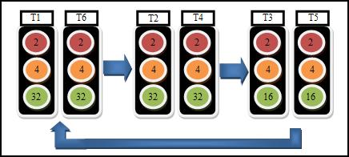

**Fig 10.2 The control scheme (fixed-time) during peak hour**

At a condition where only Sensor 1 is being set off, other cycles are the same as in Figure 2 except that T3 and T5 cycle will be replaced by T3 and T6, and both will turn green for 8s. When only Sensor 2 is triggered, cycles are similar to that during only Sensor 1 is activated except that in the last cycle flow, T2 and T5 will turn green instead of T3 and T5. At a time when both sensors are not activated, the cycles for T3 and T5 will be skipped.

**10.3 VHDL MODEL**

Fig. 3 shows the VHDL model of the controller. The model consists of:

* **CLOCK:** System clock.
* **RESET:** System reset.
* **PEAK:** Represents peak hour (1) and off-peak hour (0)
* **OUTPUT (17 DOWNTO 0):** All represents the six traffic lights (time three different output combination) that the system is going to control.
* **SENSOR1** and **SENSOR2:** Represent the two sensors used to detect the presence of car at the narrow road, T3 (Sensor1) and T5 (Sensor2).

In terms of system implementation, the approach is to develop a low cost, high efficiency TLC system. El-Medany and Hussain suggested every intersection to be equipped with sensors. In contrast, this system only requires sensors to be present at the small roads where the traffic is not heavy thus reducing significant amount of component needed. However, this system is not solely dependent on the sensor input, as it is also equipped with a clock that is used to set the “peak hour”. This is the period where both sensors will be temporarily disabled and the traffic is controlled by a fixed-time system. This allows for many possible customization of the system to suit various traffic conditions in different types of intersection. In comparison, Liu and Chen have designed a TLC system using six timers and two specials for a very specific scenario. This system has the advantage in terms of flexibility and can be applied to various intersections with different traffic conditions.

**11. SOURCE CODE**

module tlc(

input peak,clk,rst,sen1,sen2,

output reg [2:0]t1,

output reg [2:0]t2,

output reg [2:0]t3,

output reg [2:0]t4,

output reg [2:0]t5,

output reg [2:0]t6

);

reg [2:0]state;

reg [4:0]count;

/////////////states declaration/////////

parameter s0=3'b000;

parameter s1=3'b001;

parameter s2=3'b010;

parameter s3=3'b011;

parameter s4=3'b100;

parameter s5=3'b101;

parameter s6=3'b110;

parameter s7=3'b111;

////////timer declaration//////////

parameter sec32=5'd32;

parameter sec16=5'd16;

parameter sec8=5'd8;

parameter sec5=5'd5;

parameter sec3=5'd3;

always @ (posedge clk or negedge rst)

begin

if(~rst)

begin

state<=s0;

count<=0;

end

else

case(state)

s0:if(count<sec3)

begin

state<=s0;

count<=count+1;

end

else

begin

state<=s1;

count<=0;

end

s1:if(peak==1)

begin

if(count<sec32)

begin

state<=s1;

count<=count+1;

end

else if (sen1==1)

begin

state<=s2;

count<=0;

end

else if (sen2==1)

begin

state<=s5;

count<=0;

end

else

begin

state<=s1;

count<=0;

end

end

else

begin

if(count<sec16)

begin

state<=s1;

count<=count+1;

end

else if (sen1==1)

begin

state<=s2;

count<=0;

end

else if (sen2==1)

begin

state<=s5;

count<=0;

end

else

begin

state<=s1;

count<=0;

end

end

s2:if(count<sec5)

begin

state<=s2;

count<=count+1;

end

else

begin

state<=s3;

count<=0;

end

s3:if(peak==1)

begin

if(count<sec16)

begin

state<=s3;

count<=count+1;

end

else if (sen2==1)

begin

state<=s4;

count<=0;

end

else

begin

state<=s1;

count<=0;

end

end

else

begin

if(count<sec8)

begin

state<=s3;

count<=count+1;

end

else if (sen2==1)

begin

state<=s4;

count<=0;

end

else

begin

state<=s1;

count<=0;

end

end

s4:if(count<sec5)

begin

state<=s4;

count<=count+1;

end

else

begin

state<=s6;

count<=0;

end

s5:if(count<sec5)

begin

state<=s5;

count<=count+1;

end

else

begin

state<=s6;

count<=0;

end

s6:if(peak==1)

begin

if(count<sec16)

begin

state<=s6;

count<=count+1;

end

else

begin

state<=s7;

count<=0;

end

end

else

begin

if(count<sec8)

begin

state<=s6;

count<=count+1;

end

else

begin

state<=s7;

count<=0;

end

end

s7:if(count<sec5)

begin

state<=s7;

count<=count+1;

end

else

begin

state<=s1;

count<=0;

end

default:state<=s0;

endcase

end

always @ (*) ////consider 3bit input as RYG////

///if R is active R=100//////if Y is active Y=010///

begin ///if G is active G=001//////

case(state)

s0:begin

t1=3'b000;t2=3'b000;

t3=3'b000;t4=3'b000;

t5=3'b000;t6=3'b000;

end

s1:begin

t1=3'b001;t2=3'b001;

t3=3'b100;t4=3'b001;

t5=3'b100;t6=3'b001;

end

s2:begin

t1=3'b010;t2=3'b010;

t3=3'b100;t4=3'b010;

t5=3'b100;t6=3'b001;

end

s3:begin

t1=3'b100;t2=3'b100;

t3=3'b001;t4=3'b100;

t5=3'b100;t6=3'b001;

end

s4:begin

t1=3'b100;t2=3'b100;

t3=3'b010;t4=3'b100;

t5=3'b100;t6=3'b010;

end

s5:begin

t1=3'b010;t2=3'b001;

t3=3'b100;t4=3'b010;

t5=3'b100;t6=3'b010;

end

s6:begin

t1=3'b001;t2=3'b001;

t3=3'b100;t4=3'b100;

t5=3'b001;t6=3'b100;

end

s7:begin

t1=3'b100;t2=3'b001;

t3=3'b100;t4=3'b100;

t5=3'b010;t6=3'b100;

end

endcase

end

endmodule

**12. RESULTS**

**12.1 RTL SCHEMATIC:**

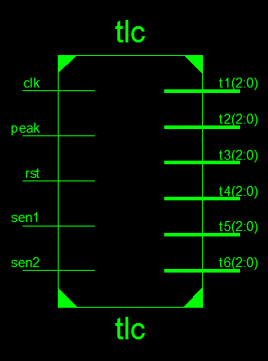

**Fig 12.1: RTL Schematic**

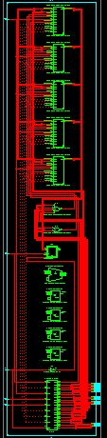

**Fig 12.2: RTL Schematics with 5 Counters, Adder, D Flip-flop, 4 Comparators, Inverter, FSM**

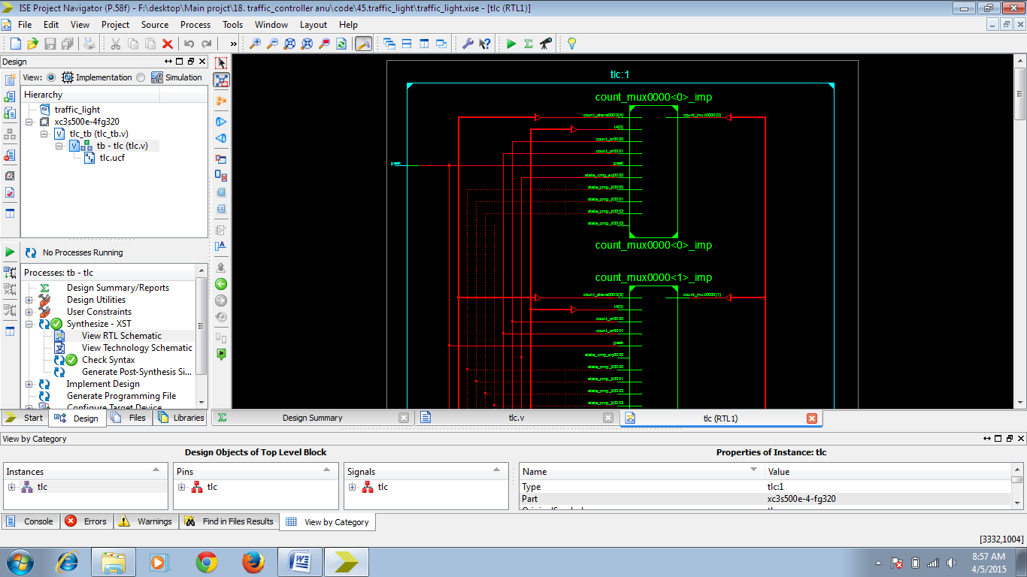

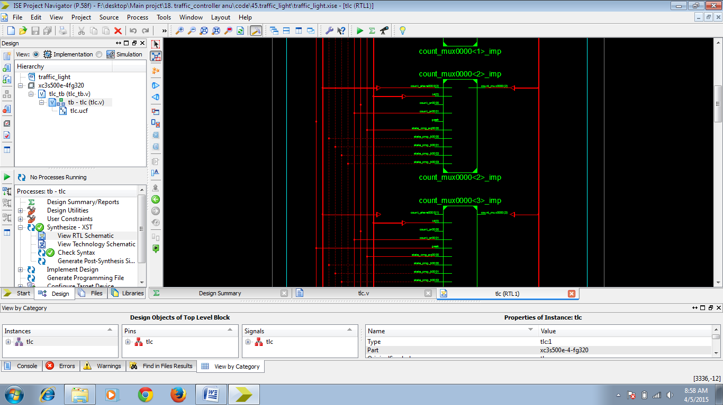

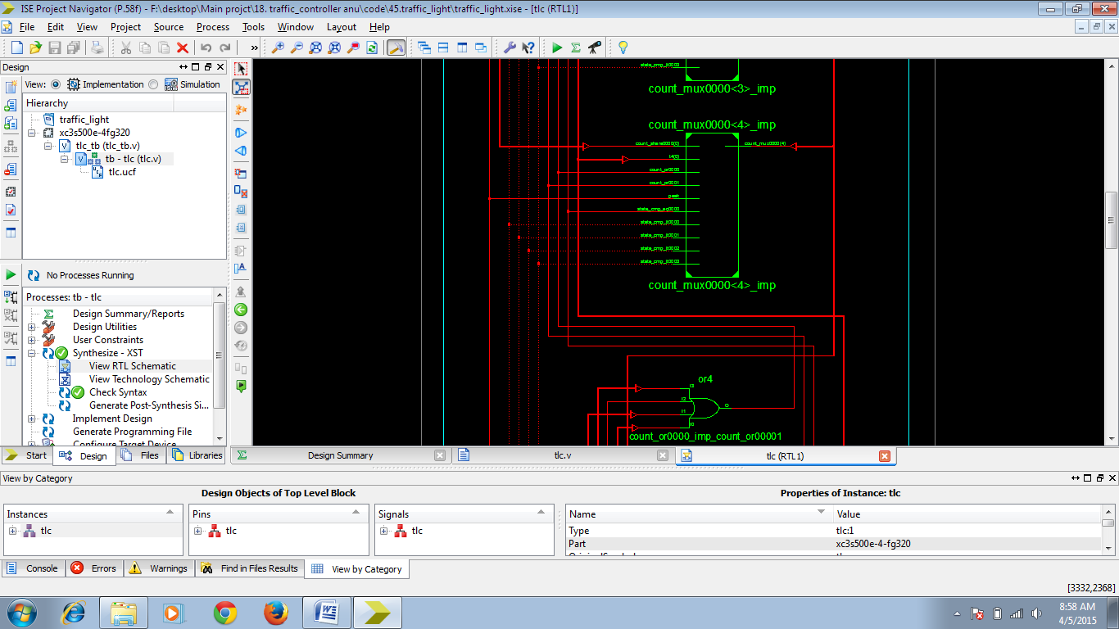

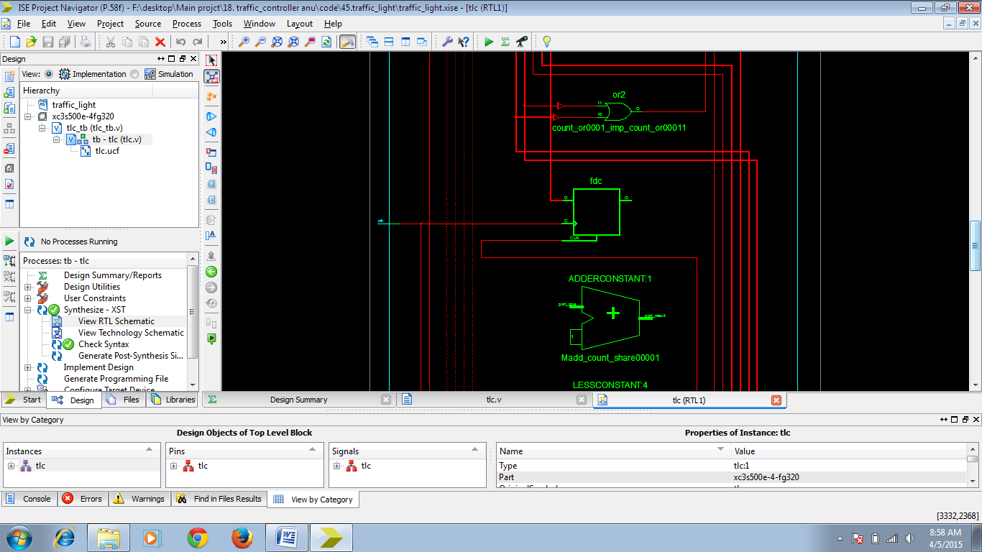

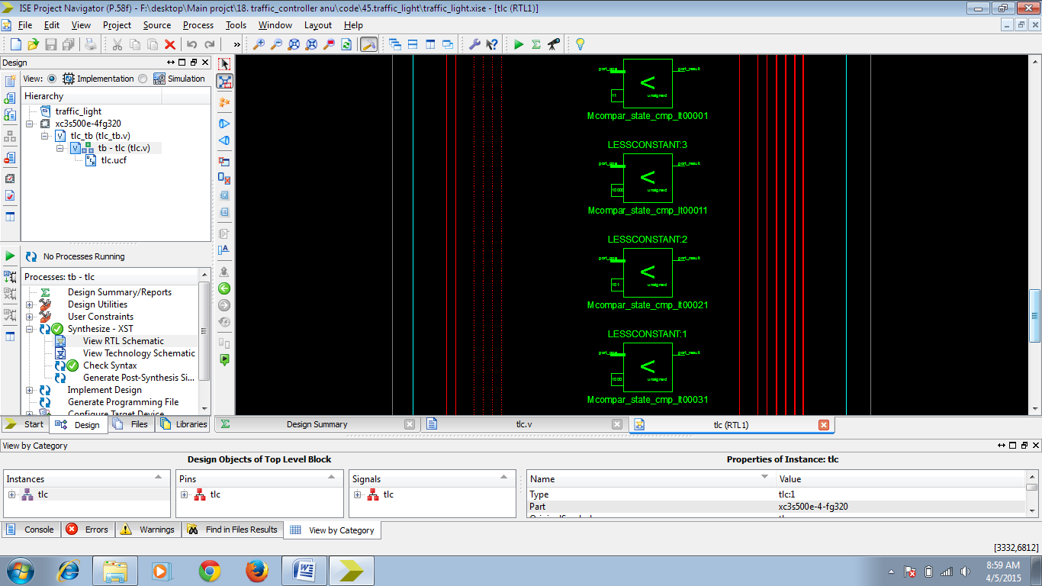

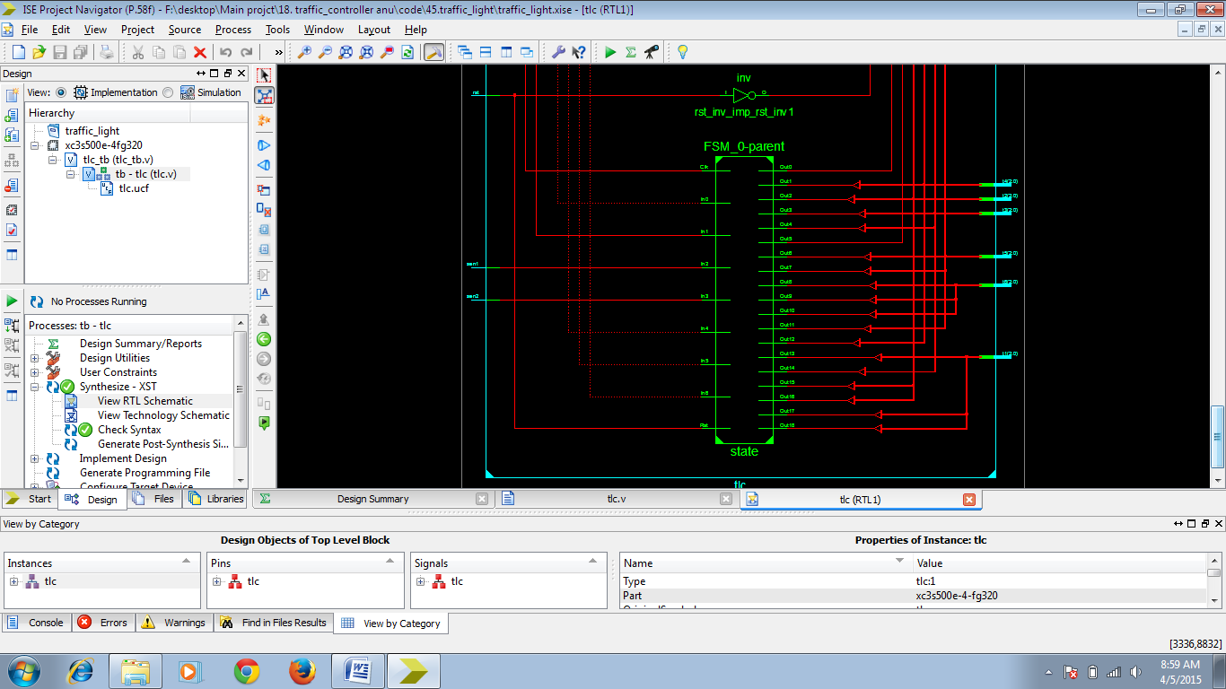

**Fig 12.3: RTL Schematics zoom in**

**12.2 SIMULATION RESULTS:**

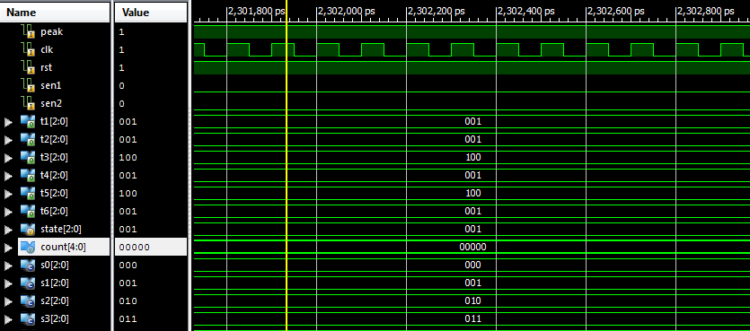

**Fig 12.4:Sensor1=0, Sensor2=0**

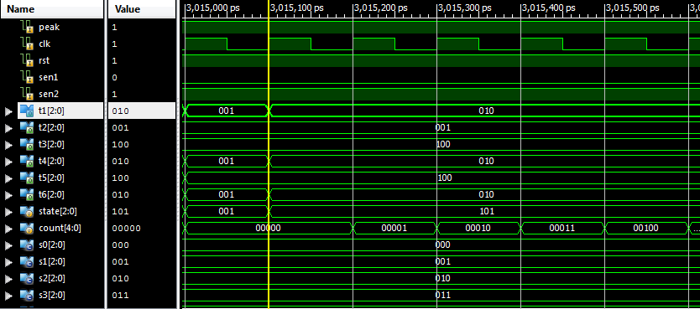

**Fig 12.5: Sensor1=0, Sensor2=1**

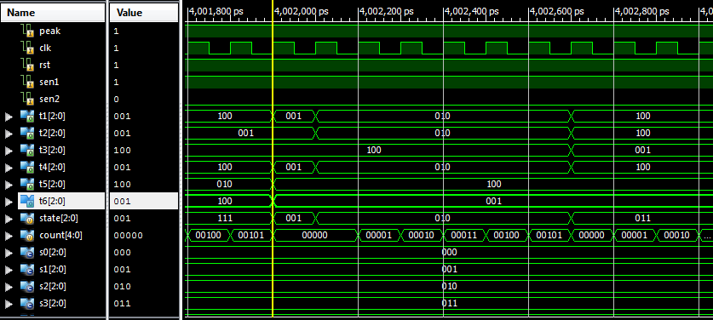

**Fig 12.6: Sensor1=1, Sensor2=0**

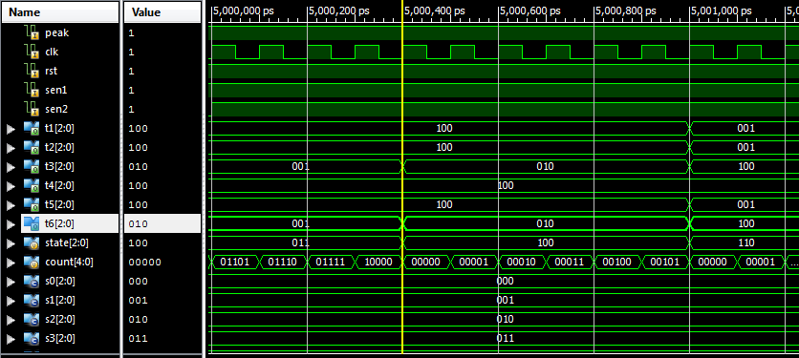

**Fig 12.7: Sensor1=1, Sensor2=1**

**13. FEATURES**

**13.1 ADVANTAGES**

* Speed of operation.
* Low power consumption.
* Easy to implement.
* Less area.
* Less wiring complexity.

**13.2 APPLICATIONS**

Ease to control the traffic signals at any junction by using Intelligent Transport System (ITS) by using Field Programmable Gate Array (FPGA).The code is written in Verilog HDL design pattern and synthesis is done in XILINX of version 14.5.

**13.3 PAST TECHNOLOGIES AND THIER DRAWBACKS**

**13.3.1 USING MICROCONTROLLER**

Present Traffic Light Controller (TLC) is based on microcontroller and microprocessor. These TLC have limitations because it uses the pre-defined hardware, which is functioning according to the program that does not have the flexibility of modification on real time basis. Due to the fixed time intervals of green, orange and red signals the waiting time is more and car uses more fuel. FPGA has many advantages over microcontroller, some of these advantages are; the speed, number of input/output ports and performance which are all very important in TLC design, at the same time ASIC design is more expensive than FPGA. Most of the TLCs implemented on FPGA are simple ones that have been implemented as examples of FSM. This paper concerned with an FPGA design implementation of a low cost 24-hour advanced traffic light controller system that was built as a project of a VLSI design subject using VHDL.

**13.3.2 USING PLD AND CPLD**

Traffic Light Control System (TLC) system can be designed on GAL (Generic Array Logic) using Programmable Logic Device (PLD) using Complex Programmable Logic Device (CPLD). For PLD implementation, we consider GAL (16V8) chips, which can be reprogrammed and erased. For the CPLD implementation, we consider FPGA (ALTERA's Flex 10k family's EPF10K10TC144-4) chip, which is a 144 pin SRAM. The CPLD design was developed using the CPLD programming software MAX PLUS2 v 9.23. The traffic light controller consists of traffic signals (Red, Yellow/Amber & Green). We have designed the traffic controller using both CPLD and PLD. Then we have taken the real time waveform as well as the simulated waveform for different frequencies. The Digital Storage Oscilloscope (DSO).was used to generate the real time wave from the traffic controllers. The results from the real time waveform clearly illustrates that CPLD has the better performance over the PLD technology. In this power consumption is high and circuitry becomes complex with number of PLD and CPLD’s. We are using a FPGA which consists of CLB by which the power consumption is lessened and circuitry also becomes simple.

**13.4 FUTURE ENHANCEMENT**

For future works, the TLC design will include pedestrian crossing lights with the intention that the reliability of the design can be much enhanced. Lastly, a comprehensive and an exceptional TLC design can be made into an embedded circuit board to control the actual traffic flow in the city’s traffic intersections.

**14. CONCLUSION**

An FPGA design of TLC with six traffic lights has been simulated using Quartus II, implemented and tested using ALTERA FLEX10K chip. One of the advantage of this design over the existing method is the waiting time of driver during off-peak hour has been reduced, means that the normal design cycle (using fixed-time technique) has been reduced notably, thus ameliorate reliability and flexibility of the TLC.

An FPGA design of a 24-hour traffic light controller system of a twelve roads structure with six traffic lights has been simulated, implemented and tested. The system has been designed using VHDL, and implemented on hardware using XILINX Spartan 3E and Virtex 5xc5vlx110t FPGA kit. The functionality of this design can be easily enhanced.

Some of these functions are to control more than 6 traffic lights. Also, to allow the user to assign the time for each traffic light (i.e., minimum time to be Green), adding more sensors on each road to count the number of cars in each road and check for the longer queue to increase the timer for that road. Here we have manually entered the signals for the NS car and EW car since the sensor interfacing is not done at yet manually entered the signals for the Ns car and EW car since the sensor interfacing is not done yet which remains as future scope as well as the camera interfacing which will detect if any car breaks the traffic rule serve as a security purpose and emergency services.

**15. REFERENCES**

* El-Medany, W.M., & Hussain, M.R. (2007) FPGA-Based Advanced Real Traffic Light Controller System Design.

Proceeding of 4th IEEE International Workshop on Intelligent Data Acquisition and Advanced Computing Systems: Technology and Applications, ISBN: 978-1-4244-1347-8, pg. 100 – 105.

* Chan, S.S., Deshpande, R.S. & Rana, J.G. (2009) Design of Intelligent Traffic Light Controller Using Embedded System.

Proceeding of 2nd International Conference on Emerging Trends in Engineering and Technology, ISBN: 978-1-4244-5250-7, pg. 1086-1091

* Liu, Y. & Chen. X. (2009) Design of Traffic Lights Controlling System Based on PLC and Configuration Technology.

Proceeding of International Conference on Multimedia Information Networking and Security 2009, ISBN: 978-0-7695-3843-3, pg. 561-563

* Kulkarni, G.H. & Waingankar, P.G. (2007) Fuzzy logic based traffic light controller.

Proceeding of International Conference on Industrial and Information Systems 2007, ISBN: 978-7-4244-1151-1, pg. 107-110

* Norhuzaimin, J. & Maimun, H.H. (2005) The Design of High Speed UART. Proceeding of Asia Pacific Conference on Applied Electromagnetics, ISBN 0-7803-9431-3, pg. 306-310.
* STEPHEN BROWN, JONATHAN ROSE*,* “FPGA and CPLD architectures: A Tutorial,” Design & Test of Computers*, IEEE*, Volume 13,Issue 2, summer 1996 Page(s):42 – 57.
* CPLD Logic Design and Practices (LP 2900manual)
* Wikipedia, “Programmable Logic device,”

http://en.wikipedia.org/wiki/Programmable_logic_device.

* Wikipedia, “Traffic light,”

http://en.wikipedia.org/wiki/Traffic_light.

* Charles H. Roth, Jr. “Digital Systems Design Using VHDL”.